VENICE BELLS AND BELL TOWERS:

A Striking Source of Knowledge

AN INTERACTIVE QUALIFYING PROJECT

WORCESTER POLYTECHNIC INSTITUTE

Submitted to:

Project Advisor: John Zeugner, WPI Emeritus Professor

Project Co-Advisor: Fabio Carrera, WPI Professor

Submitted by:

Fredrick Baruffi

Janelle Boucher

Madalyn Coryea

Danielle Spector

Date: December 15, 2012

[ve12-bells@wpi.edu](mailto:ve12-bells@wpi.edu)

<https://sites.google.com/site/ve12bells/blog>



**Authorship Page**

The authors of this document are Rick Baruffi, Janelle Boucher, Madalyn Coryea, and Danielle Spector. These four WPI students had equal parts in the writing of this report.

Table of Contents

1.0 INTRODUCTION 7

2.0 BACKGROUND 9

2.1 Bells 9

2.1.1 History of Bells 9

2.1.2 The Anatomy of a Bell 10

2.1.3 Bell Casting/Founding 10

2.1.4 Bell Decoration 11

2.1.5 Deterioration of Bells 11

2.1.6 Bell Frame Designs 12

2.1.7 Bell Ringing 13

2.2 Bell Towers 15

2.2.1 The Anatomy of a Bell Tower 15

2.2.2 Bell Tower Styles 16

2.2.3 Deterioration of Bell Towers 17

2.3 Past Work 18

2.3.1 Initial Projects 19

2.3.2 Other Research 20

2.3.3 Most Recent Project 20

3.0 METHODOLOGY 20

3.1 Systematically Arranging Bell and Bell Tower Data 21

3.1.1 Preserving Data and Materials 21

3.1.2 Cataloging Objects 21

3.1.3 Organizing Information 22

3.2 Integrating New and Updating Old Information on the Bells and Bell Towers in Venice 24

3.2.1 Video Capture 27

3.2.2 Audio Capture 27

3.3 Distributing Collected Bell Data to the Public 28

3.3.1 Venipedia 28

3.3.2 Website 29

3.3.3 Smartphones 29

3.3.4 PreserVenice Venice Public Art App 30

4.0 BELLS OF VENICE 30

4.1 Bell Sizes 30

4.2 Ringing Methods 31

4.3 Bell Condition 32

5.0 BELL TOWERS OF VENICE 33

5.1 Sestiere 33

5.2 Height 34

5.3 Bells per Tower 35

6.0 RECOMMENDATIONS 36

6.1 Visiting Towers and Data Collection 36

6.1 Alter Data Collection Forms 36

6.3 A New Database 37

6.4 Mobile Application 37

6.5 Financial Analysis 37

6.6 Sound Analysis 38

5.0 Conclusion 38

5.0 BIBLIOGRAPHY 39

Appendix A: Budget 45

Appendix B: Venipedia Templates 46

Appendix C: Field Forms 49

Appendix D: Week One Schedule 62

Appendix E: Our Tentative B term schedule 63

**List of Tables**

Table 1: Illustrations of different Bell systems 11

Table 2: List of architectural styles of bell towers 14

Table 3: List of data collected by past projects compared to data we wish to obtain 23

**List of Figures**

Figure 1: An example of a pristine bell from the 2004 WPI project 7

Figure 2: Parts of a Bell 10

Figure 3: Possible infographic showing level of deterioration of bell towers 15

Figure 4: Tower of Finale Emilia after earthquake 16

Figure 5: "Bell Master" page from 2004 Database 20

Figure 6: Chiesa di S. Geremia e Lucia Q1 video 20

Figure 7: Map of Bell Towers in Venice 21

Figure 8: An example of a Smartphone running our application 25

Figure 9: An example of how our application will appear to the user 27

Figure 10: Graphical representation of our product 27

# 1.0 INTRODUCTION

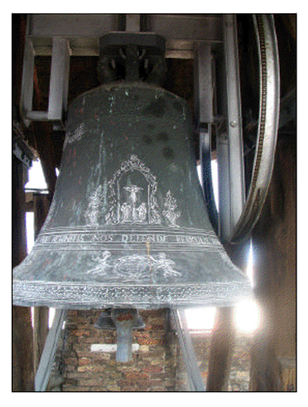Bells are one of the few simple objects that have withstood the test of time and have held an important position in cultures across the world. They have been used as alarms for fire or incoming enemies, signals for times of worship and death, and have even been rung in order to lift spells.[1] Since they served such crucial purposes, it was essential for bells to be heard over great distances. With bells positioned high up in bell towers, entire communities could hear them ringing. Unfortunately the development of new methods of communication has stripped these aging devices of many of their important functions. Bells, though not as significant a method of communication as before, still represent a great era of history. Since they are not being used, bell towers have been neglected and ignored resulting in the damage of precious artwork on the bells inside. Being a physical record of societal and technological advancement, it is important to preserve bells.[2]

Like bells found in other cities, the bells of Venice have lost most of their significance and thus their ability to captivate an audience. The increasing neglect of bell towers has left many bells in bad shape, some bell towers in a state of disrepair, and in extreme circumstances some towers near collapse. Even bell ringing, once an art form in itself, has been largely replaced by automated systems reducing what little human interaction the bells received in recent history. Left alone to combat the harsh elements of Venice, the bells will continue to degrade and if left unchecked the damage to these pieces of art and history could be more than dollars and cents. When Venice was inducted as a cultural heritage site, the United Nations Educational, Scientific and Cultural Organization (UNESCO) endorsed the conservation of Venetian culture, which the organization believes to be an “irreplaceable source of life and inspiration.”[3] Therefore, with the guidance of UNESCO’s ideals we are charged with the difficult task of creating a context for people to care about the bells once more.

Figure 1: An example of a pristine bell from the 2004 WPI project

Indifference is the major issue preventing the bells of Venice from being appreciated.  The majority of bell towers are inaccessible to the public which severely limits any direct contact with Venetians and tourists.  Denied to the public and hidden away in tall towers, the bells are not intimately incorporated in a person’s daily life making it difficult to encourage people to care about these secluded structures.  The World Heritage Convention recognized the importance of creating a personal investment in tangible culture in order to preserve the local heritage.[4]  Although the preservation of bells and bell towers has not been a priority for UNESCO, their goals and the goals of the Venice Project Center in preserving culture and educating the public have been similar.

To address these issues, research was conducted in 94’, 95’, 96’, 97’and 04’ by the Venice Project Center to preserve some data about the bell towers in Venice.  The Project Center began studying bells in 1994 when the first project produced and tested a methodology for the collection of data on ten bell towers. In the following year, the next group was able to improve upon the methodology and study twenty-three more towers. In 1995, 1996, and 1997, Earthwatch volunteers were recruited to use the methodology of the previous first two projects to collect data and record videos. Bells were revisited in 2004, when a group developed a Microsoft Access database and collected and updated new and past information. Most of the past work on this topic has had to do with bell towers, not bells. Due to changing technology, the video captured by Earthwatch volunteers and the 2004 project is often incorrectly labeled and poor quality by present standards. Also, no project has yet to study all standing towers or bells in Venice. Most importantly, data from these projects are neither up-to-date nor located in a publicly accessible database.

The goal of this project is to prevent the bells from losing significance as a part of Venice’s material culture by eliminating the knowledge gap. Building upon the efforts of previous Venice bell teams, we standardized the data by visiting and documenting bells and bell towers that had not been recently surveyed and updating information when their existing data was outdated.  Once all data were compiled it was organized and inserted into a digital database known as Venipedia. This contribution gave the city of Venice a digital form of all its history and current data on bells and bell towers.

# 2.0 BACKGROUND

Material Culture is the set of objects that define the social identity of a society. In the case of Venice, bells and bell towers have become a part of this culture because there are so many of them and they both have been considered an art that captures history. For bells it is in their function, inscriptions, engravings, and sound. For towers it is in their architecture that characterizes the landscape of Venice. To preserve bells and bell towers, people must not only physically restore them, but document the information in a way that is accessible for anyone. Appreciation precedes action; therefore if people understand the importance of bells to material culture and know of their condition, they will be more willing to make an effort to preserve them.

## 2.1 Bells

Bells exist all over the world. From China to Europe to America, some bells stand high in stately towers so that their tuneful sounds can be heard from the widest possible radius. Before modern times, these bells had more purpose than pure musical entertainment. They were signals of danger, disaster, and alarm. With improvements in technology and communication, bells are not of the importance they once were, but most people fail to realize that they are a portal to our past. Many bell towers of today were built in medieval times, and were manufactured using a specific set of techniques and materials. The bells of the past were carefully planned out and constructed, without even the most minute detail cast aside. From the precisely tuned pitch, to the carvings on the body, bells were designed by a dedicated artist.

### 2.1.1 History of Bells

The beginning of bells dates back to 132 A.D. in China.[5]  The idea came from a Chinese philosopher by the name of Chang Heng.  He invented the first known earthquake detector.[6]  The structure operated with an internal pendulum mechanism that would swing due to the earth’s tremors. This pendulum would then hit a ball out of one of the structures’ eight openings, not only alerting of an earthquake, but of its direction.[7]

Bells then migrated to Europe where they were modified, becoming greatly popular in the medieval time period.[8]  When churches in Europe adopted bells, they put them up in steeples to signal churchgoers when to attend mass or when to pray.[9] In modern times, some churches still ring their bells for the same reasons.

### 2.1.2 The Anatomy of a Bell

All church bells have similar features. There is the crown, in which the vibrations mostly come from and the shoulder, which is the curvature at the top. The part that induces the sound, in most cases, is the clapper which is the long piece that hangs from the top of the inside of the bell. When swung it hits the strike point, or soundbow, of the bell. Figure 2 below labels the parts discussed.

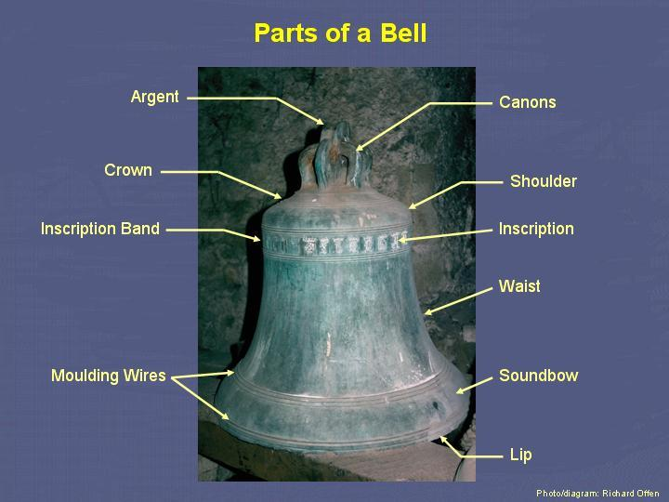

Figure 2 Parts of a Bell

### 2.1.3 Bell Casting/Founding

The casting of bells is a delicate and precise process. The style of a particular bell depends upon the foundry in which it was made, along with the materials that compose it and the period of its creation. Bells have typically been made using the same process for over six centuries.[10] A popular method of bell casting is to use sand-casting.[11] In medieval times, when many bells were being produced, molds were made from clay to make a template for the bells. A bell mold had a center mold and an outer mold, where molten bronze was poured between the two and then allowed to cool to take the shape of a bell.[12] Back in the middle ages, sometimes wooden templates were also used. Through the use of these templates the distinctive shape of the bells was formed.

The most common material for bells is bronze, an alloy of copper and tin.[13] Very rarely bells were cast in steel and cast iron.[14] This shift in bell materials occurred mainly during times of war, when alloys such as bronze were in short supply since copper was needed in the manufacturing of some weapons.[15] Around 1857 A.D. a combination of iron and carbon, also known as steel, became a material for bell-making. Not soon after it had begun being used it was discarded since the compound was deemed unsuitable for a material of bells. Steel was discarded due to the poor sound quality that it produced, as well as its relatively brief lifespan.

### 2.1.4 Bell Decoration

Most European bells are similar in their decorations, which usually include an inscription about where or when they were made or an engraving of a religious figure. Rev. Geo. S Tyack’s book, *A Book about Bells,* thoroughly explains English bells, but can also be applied to Venetian bells. The author describes how bell makers were known for their bells by the designs they used to distinguish themselves. For instance, Oldfield, an English maker from the seventeenth century, used a classic foliage design as a border around the shoulder and lip, while Purdue instead molded a grape vine design.  Another trend founders have implemented was to design a trademark with a symbol or initials instead of writing out the full name of the founder[16].

Historical figures are another common form of art found on bells. These include effigies of saints, angels, or royal leaders. In addition, one may find the shield of the patron who invested in the tower or church. However, the most frequently used decor were inscriptions which offer information of whom the bell was dedicated to, who the maker or donor was, when it was caste, and other supplemental information.[17] These are typically in Latin, although some may be in the native Italian. There have also been some cases, in England, in which an inscription on a bell has defamed another founder. When change-ringing was first introduced, bells had inscriptions that would refer to the order in which they were rung.[18] And, others may have a verse or couplet, on something historical, religious, or pertaining to the bell.

When ancient bells were caste, the moldings and decor on them were treated as a form of art. The inscriptions, figures, and design on each bell were well thought out by the founder and were intended to be a reflection of the founder’s work.

### 2.1.5 Deterioration of Bells

Although modern technology has reduced the need to ring the bells manually, it has resulted in people being removed from the process of maintaining those bells. Most of the bells in Venice, being made of bronze, suffer from a cyclic degrading process known as Bronze disease. The disease refers to a chemical process in which the copper in bronze reacts with elements and moisture in the atmosphere creating what is known as a patina, in this case, a film signifying corrosion.[19] Patina on bronze is composed of two layers. The first is a thin dark brown layer consisting of copper oxide which conforms to the surface of the object.[20] The second layer, best known for its characteristic greenish color, consists of copper sulfides and chlorides.[21] Patina formation is affected by several factors including temperature, relative humidity, duration and intensity of rain, mist, dew, sun radiation, direction and intensity of wind, and atmospheric pollution by sea salinity.[22] Bell towers provide perfect conditions for Bronze disease to propagate by leaving bells exposed to environmental conditions such as humidity, high winds, rain, and moisture.

The process of Bronze disease is facilitated by moisture and dry air. Initially the copper in the bronze reacts with the salt and sulfates in the air to create copper chloride and copper oxide. The oxide is relatively harmless; however, the chloride causes damage.[23] The copper chloride reacts with moisture to create hydrochloric acid which reacts with unaffected bronze to create more copper chloride thus continuing the cycle.[24] Eventually equilibrium is reached where there is no more bronze on the surface to cause a reaction.[25] Oddly enough the corrosive green patina layer acts as a thick buffer from future deterioration.[26] However the thick green coating has the ability to transform the object by corroding the surface and possibly removing valuable artwork from its face.[27], [28] Many of the bells have intricate images exuding from their surfaces making corrosion a significant problem.

### 2.1.6 Bell Frame Designs

Two bell frame types are primarily used to suspend bells, the H frame and the A frame. The H frame (See Figure 2) occurs when the bell is suspended on a “cross bar made of heavy H castings” usually composed of a durable metal material such as cast iron.[29] The metal material resists twisting and provides a secure base for the bell.[30] The popularity of this type of design resides in its “greater convenience and construction.”[31]

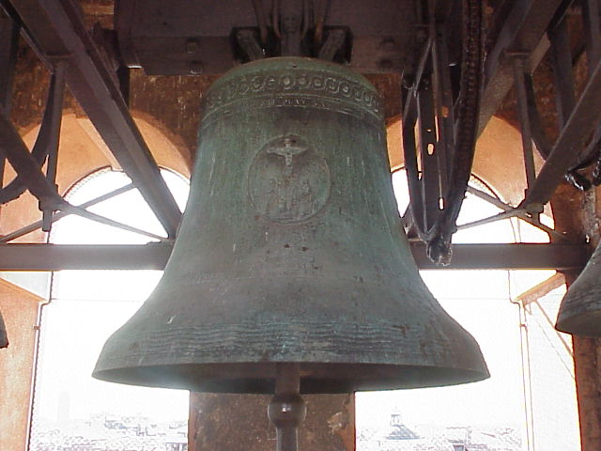

Figure 3 Example of H frame (San Felice)

The second frame design is the A frame (See Figure 3) which, as the name suggests, is a frame in the shape of an A which supports the bell. This type of frame is, physically, more sound than the H type because it manages to distribute the weight properly and as a result relieves most of the stresses seen by the H type.[32]

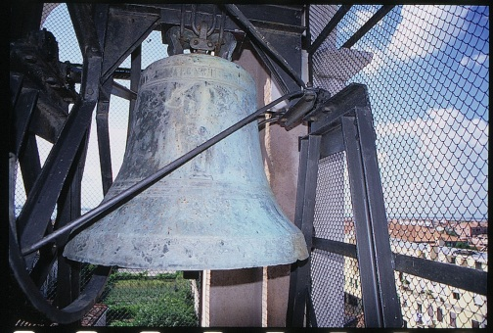

Figure 4 Example of A frame (Santa Maria di Nazateth Scalzi)

### 2.1.7 Bell Ringing

Bells don’t have one uniform way of being rung. In fact, the number of ways of ringing bells is almost as diverse as bells themselves. Asian bells, which are never suspended, are usually struck from the outside with a wooden mallet or a horizontal wooden beam in order to produce a sound.[33] Western bells, commonly found in churches, are categorized by three types of swinging systems; English, Spanish, and Central European.[34] However, they all have the common trait of being struck by a piece of metal otherwise known as the clapper.[35]

The English system, utilized in Britain, Ireland, USA, Canada, Australia, New Zealand, Southern Africa, and Northern Italy is characterized by its 360° motion where the bells freely make full circles.[36] The Spanish system is common in Spain, Southern France, USA, and in some Latin American countries and consists of bells mounted in a window with a counterweight causing the bells to rotate in the same direction.[37] Finally the Central European type, found in Central Europe, USA, Canada, Italy and in some Latin American Countries, commonly attaches counterweights to the tops of the bells which only allow them to swing a total of 160°.[38]

|  |  |  |
| --- | --- | --- |
| **Spanish Bell System** | **English Bell System** | **Central European System** |
|  |  |  |

Table 1: Illustrations of different Bell systems

Swinging bell types can be further divided into four ways. The first way “clocking,” occurs when a rope attached directly to the clapper is pulled against the bell to strike it.[39] The second, known as “chiming” or “tolling,” involves an external hammer which is either controlled by hand or by machine.[40] “Tooling,” the third way for a bell to swing has a rope attached to the bell directly and the bell itself is swung.[41] This can be extremely difficult, near impossible, considering bells can weigh as much as several tons. The final method is “ringing” during which the bell is swung from side to side typically on a wheel.[42] This type is the common method used in the previously discussed swinging systems.

The “ringing” method can be accomplished in two ways; a “flying” clapper and a “falling” clapper. A “flying” clapper begins with a bell attached to the pivot point of what is known as a “headstock” or “yoke” generally composed of either wood or steel.[43] A pulley system is attached to the yoke from which a rope is fed and pulled to rock the bell which causes the clapper to swing freely or “fly” (English system) and strike against the bell.[44] A “falling” clapper involves a counterweight (Spanish system) attached to the yoke “allowing the bell to pivot with a high center of gravity”.[45] The clapper initially hangs at the pivot point and “falls” onto the walls of the bell with changing directions.[46]

While most of the previously discussed information suggests manual ringing of the bells, a popular trend has developed in which the bells are governed by an automated system. A common type of automated system involves a motor with cables leading up to either side of the bell wheel.[47] The motor is activated when the bell reaches the peak of its swing by spinning the cables in the opposite direction which, in turn, reverses the bell’s direction.[48] A drawback for this system was it couldn’t monitor the state of the bell in case its swinging became erratic which was later remedied by a group that outfitted the motor with a computer which would halt the bell in case of malfunction.[49] Another automated ringing system involves a mechanized striker which can be installed either on the outside of the bell (often used for swinging or stationary bells) or on the inside (only used for stationary bells).[50]

## 2.2 Bell Towers

Bell towers may often look very similar to the casual observer, but when one looks closely at the minute details, he or she may find that the differences are numerous depending on the part of the tower being studied and the time it was built.

### 2.2.1 The Anatomy of a Bell Tower

There are four main components to the structure of a bell tower: base, shaft, belfry, and spire. Each of these contributes to the overall style and integrity of the tower.  
        The main purpose of the base is to maintain the structural integrity of the tower. The walls at the base of the tower are often thicker than those at the top. Non-porous materials are 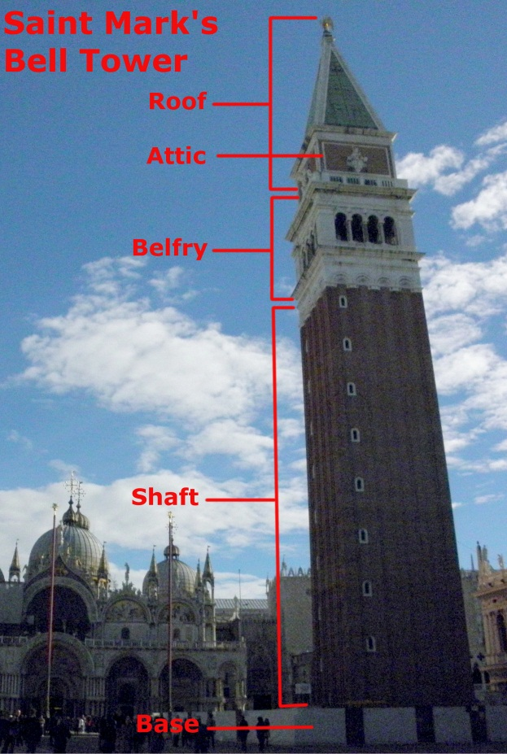used so that it is resistant to salt water from flooding and heavy enough to withstand the pressure from the weight of the tower.  
        The shaft is the part that contributes to the height of the tower and contains stairs, ramps, and landings that lead to the belfry. It is usually constructed of brick and mortar, which varied in strength based on the year that it was constructed. Brick makers improved upon the method for making bricks so that bricks could withstand a greater amount of pressure. In addition, to provide the tower with greater flexibility and support, some towers were built using metal rods.  
        The belfry, located above the shaft, contains the bells and usually some type of landing. On the exterior, it is generally the most ornate part of the tower, built using brick and other types of stone or clay. Typically, there are windows or arched openings that let light through and occasionally netting to keep pigeons from entering. The bells are hung from the top of the belfry with wood, although some newer towers use metal. It has been found, however, that the vibration of the bell through the metal to the walls increases deterioration.   
 Above the belfry there may be an attic which provides additional storage or access to the top of the tower for maintenance. There may also be a balustrade, or a balcony with a railing that runs around the outside of the attic. This is usually accessible from the attic, so that one may enjoy a more expansive view and have additional access to the roof. To get to the attic, there is either a ladder or stairway.   
           The spire varies depending on the tower, but it can have many shapes: conical, pyramidal, bulbous, and others. There also may be a lightning rod or weathervane at the top of the tower.

Figure : Diagram of the parts of a bell tower

### 2.2.2 Bell Tower Styles

Venice bell towers, along with the bells they hold, have been a constant part of daily life for citizens for over a thousand years. Essentially, each tower displays the same set of basic features: a tall square base, usually attached to a church, an opening for the bells, and a spire or dome on the top. Depending on the time of construction, bell towers differ in features such as type of opening, type of roof, material, and decoration. Because of age and deterioration, many of these towers require restoration usually having to do with weak foundations.[51] When towers were restored, the new parts often reflected the time period in which it was restored and not the period in which it was built. Therefore, towers frequently feature multiple styles of architecture.

Styles that were close in time period may share some of the same features. For instance, Baroque and Renaissance towers often have marble columns to separate openings in the belfry. In addition, earlier towers, such as towers from the Romanesque era, were very simplistic, showing little to no artistic design. Later towers, like those from the Baroque period, became more detailed.

Overall, bell towers contribute a great deal to the ambiance of the city. They add a new dimension to the landscape of Venice. Just as the New York skyline is seen as an iconic image throughout the world, the bell towers of Venice bring a vertical dimension to an otherwise flat city.

### 2.2.3 Deterioration of Bell Towers

Catastrophic events such as earthquakes and flooding do not frequently cause any major damage, but there have been cases, not specifically in Venice, where this has occurred.

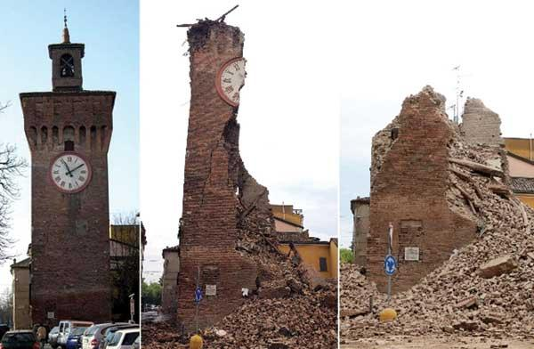Seismic activity is but one danger the bell towers of Venice must face.  Earthquakes have rocked many towers to the ground through the centuries (See Figure 4), with one of the most recent incidents happening in 1902 when the bell tower in the Piazza San Marco collapsed.[52]  When originally built, these monuments were intended to support the vertical force of gravity rather than horizontal shifting forces from earthquakes.[53]  Furthermore, clay soil at the foundation of the towers causes a large amount of weight to be displaced over a small area, leading to instability.[54] As a result, some bell towers in Venice have struggled to remain standing.

Figure 6: Tower of Finale Emilia after earthquake

The damaging effects of flooding in Venice were brought to international attention on November 4, 1966 when the water level rose 1.9m above standard water level.[55]  This flood caused innumerable costs of damage to the cultural heritage of Venice including art and architecture.  Since then flooding has become more noticeable each year than in previous years.  In the past century the water level has risen by about 12 cm which is believed to be caused by global climate change and the resulting increase in sea level.[56] Flooding is presumed to worsen with increasing subsidence of land.  The number of instances of flooding is projected to increase 20 to 250 times by the end of the 21st century.[57]

           The effect of water levels on historical monuments is significant.  It affects the foundation by eroding away supports and softening the soil with sediment deposits. In addition, many basements in Venice consist of water-resistant stone: however, the rest of the building is vulnerable to rising water levels.  The brick exposed to flooding is weak against the intrusion of water as it enters through its porous surface and creates crystallization of salt.[58]  This chemical reaction causes damage to the façade of the building in the form of weathering and deterioration, as well as causing problems in the form of weakening the building’s structural integrity.

Damage due to flooding is a major issue affecting Venice because it leads to deterioration of material culture. This deterioration is an issue recognized in Venice and globally by UNESCO and other organizations. Thus their efforts to explore ways of preservation began.

## 2.3 Past Work

A great majority of the data presented in our project comes from the past projects completed by WPI students from the Venice Project Center, the work of the Earth Watch volunteers led by Fabio Carrera, and research by art historian, Adriano Boccardi. These projects focused on the collecting of data for all bells and bell towers in Venice, and the data collected ranged from the physical appearance of the towers and bells to ratings on condition to media, including video and photo. The projects also made recommendations on how to revive the significance of bells and bell towers so there might be more interest in preserving them.

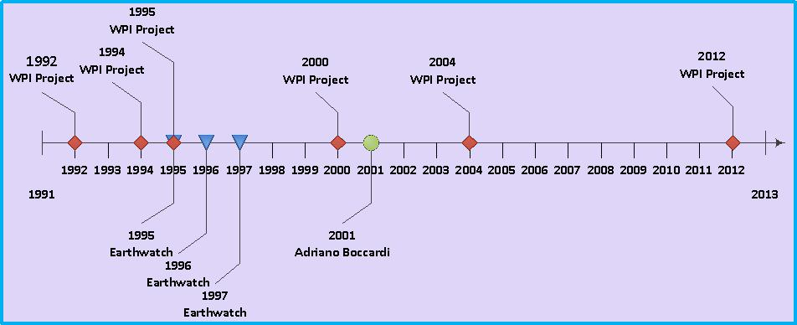

Figure 7 Timeline of past research on Venice Bells and Bell Towers

The first project done by the Venice project Center on Venice bells and bell towers was in 1992; however, the methodology for collecting data was not refined until the 1994 Project, entitled A Method for the Evaluation of Venetian Bells and Bell Towers. The next year, another project, Computerized Catalog of Venetian Bells and Bell Towers, worked, again, to catalog the bells and also organize the data into a Microsoft Access database. In 1995, 1996, and 1997, Earth Watch volunteers, led by Fabio Carrera, used the guidelines of the two projects before to collect data and input it into the database. Towers were not revisited by the Venice Project Center until 2000, when the project, Cellular Bell Towers, proposed using the towers as cell phone towers, giving them a new function altogether. More recently, the towers have been put into the hands of the city, for their meteorological use in signaling high tides. The work of Adriano Boccardi, in 2001 contributed to the much of the information in the Project Center’s database. Although, the most recent and up-to date project was Preservation of Venetian Bell Towers, produced in 2004 by a group of WPI students studying at the project center. This project dealt with organizing the data from past projects and assessing the structural integrity of the towers as well as filling in information gaps from previous projects. The projects described have made enormous stride in providing a comprehensive source of information to the project center; however, it was never made available to the public.

### 2.3.1 Initial Projects

The main concern of this project, entitled A Method for the Evaluation of Venetian Bells and Bell Towers by Morillo and Rosas, was to establish a methodology for the set of data to be collected at each tower, including what is recorded and how it is measured. This project reviewed literature on the structural and aesthetic elements of bell towers to come up with the fields that would need to be included in their data. With these in mind they laid out the procedure for how groups should record data and tested this procedure on a sample population of bell towers. From their data, they reviewed each bell tower to decide the urgency for restoration and prioritized its need by a visual assessment.

The main focus of the WPI project entitled Computerized Catalog of Venetian Bells and Bell Towers by Carlson, Prince, and Roosa, like the 1994 project, was to improve the research methodology, which was used later by Earth Watch volunteers. They made some drastic changes to the procedure set by the group before and again tested it on a sample of eight bell towers. To store the information collected, the group designed a Microsoft Access database for future groups to use as well as MapInfo layers to display the towers they had visited.

From 1995 to 1997, Professor Fabio Carrera led groups of EarthWatch volunteers in collecting data using the methodology set out by the 1994 and 1995 project groups. The EarthWatch volunteers are responsible for collecting the majority of the data found in the Microsoft Access database as that was their only task at hand.

### 2.3.2 Other Research

The main focus of the WPI project entitled Cellular Bell Towers, was to explore ways of reviving the significance of bell towers by brainstorming alternative uses. Their main idea was to use the towers as cellular towers. Their goal was to analyze whether their idea was realistic or not by visiting the towers and taking measurements. After visiting 54 towers, the group determined that this was a feasible idea because they were so tall and distant from the public. However, the idea met resistance with the clergy owners of the towers and was never executed.

Adriano Boccardi, an art historian interested in the work of the WPI projects, developed his own methodology for observing each tower and more specifically the bells. He was concerned with the inscriptions and decorations on the bells and transcribing them with accuracy. He found that the inscriptions and artwork would often provide more information about the bell or church. His work contributed a great deal of information to the data collected by past groups.

### 2.3.3 Most Recent Project

The main concern of the WPI project entitled Preservation of Venetian Bell Towers by Marion, Milkin, Mill, and Vitone, was to continue collecting data as well as analyze the structural integrity of the towers to determine which ones needed to be renovated. In addition, they updated the methodology used by the previous groups of WPI students and EarthWatch volunteers.

# 3.0 METHODOLOGY

The goal of this project is to help preserve the material culture of bells and bell towers in the city of Venice by gaining knowledge on their historical significance and by creating an extensive source of information that will reconnect modern Venice with its past. This study includes pertinent information to the history, size, sound, and aesthetics of these bells and bell towers. Video and sound recording was limited to whether permission was granted to gain access to bell towers. Because of the seven week time constraint, we gathered as much bell data and recordings from as many bells as possible while in Venice. In order to accomplish our goal, we achieved the following objectives:

1. Systematically arranging bell and bell tower data

2. Integrating new and updating old bell and bell tower data

3. Distributing bell and bell tower information to the public

4. Exploring potential approaches to revive the significance of bells and bell towers in Venetian material culture

## 3.1 Systematically Arranging Bell and Bell Tower Data

Our first task, organizing existing data, was partially completed while we were still on the Worcester Polytechnic Institute (WPI) campus.

### 3.1.1 Preserving Data and Materials

Documenting and cataloging data and materials from different artifacts not only allow visitors to appreciate a different way of life, but it also allows the people of that culture to better define how they are viewed by a global community. By embracing the culture from which they come, citizens are able to govern a city’s outward appearance and commercial appeal. From an economic standpoint, cultural industries make up a large portion of most economies throughout the world.[59]

### 3.1.2 Cataloging Objects

Creating an accurate, publicly accessible database that provides a comprehensive understanding of any topic will allow for the sharing of information that the user will find relevant to their search. As long as the database is reliable, it can be a useful source of information on a particular subject. Databases provide for an increased efficiency of searching; relevant information will be maximized while time searching will be minimized.

           To organize data, it is essential to create a data structure, which is the primary method of planning and grouping data and metadata. In addition, the formatting of data itself must be uniform in both ordering and syntax.  Some guidelines to keep in mind are to establish a set of vocabulary which will be used when referring to data and to set rules for capitalization, punctuation, language, and spelling.[60] Some books, such as *The Anglo-American Cataloguing Rules* (AACR) and the *Describing Archives: A Content Standard* (DACS) set strict standards for the formatting of data content.[61] However, items that need organizing often do not fit the standards set forth by these resources. Therefore, the rules can be altered to fit specific objects.

Before the cataloguer can start organizing data, he or she must ask what object is being catalogued. Is it something singular or can it be split into multiple components?[62] For instance, is it a single bell or a set of bells found in a certain bell tower? Also, what played a role in the creating of this object, and what are the physical features of the object? The amount of information to describe the object is up to the designer, but it must be consistent for every item in that particular category. However, the cataloguer must be aware of the needs of the user. For example, when discussing bells and bell towers, you could provide information that a visitor would find useful, such as the sound and whether or not the tower is publicly accessible. Conversely, if you were working on a restoration project you may want to know about the age, the size, and the wear of the bells and bell towers. In addition, the more in depth the cataloging goes, the more helpful it will be for the user.[63] If not enough information is available to describe the object, the broader term should be used. Of course, the user is most important when deciding how to organize data, because if he or she cannot understand the terminology or cannot navigate the data structure, then the archive serves no purpose.[64]

### 3.1.3 Organizing Information

The projects we focused on were conducted by Earthwatch volunteers in 1995, 1996, and 1997 and WPI Venice project teams in 1994, 1995, and 2004.  The 2004 project was our main source of data, as it catalogued dates, architects, history, physical features, structural integrity, and other statistics of the bells and bell towers that they researched. Although the 2004 team only visited nine bell towers, their database provides information collected from all of the projects. A full list of measured quantities can be found in Appendix C. Most of the information the team collected is stored in a Microsoft Access database (see Figure 5), in which links to information were broken and inaccessible.

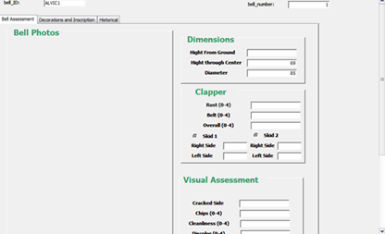

Figure 5: "Bell Master" page from 2004 Database

Our group learned to get around the broken links by going into the individual database pages and exporting the information into an excel spreadsheet.  The information from the 2004 database was cross referenced by another access database created by Adriano Boccardi who compiled detailed information on bells specifically.  This was so we could manually take the raw information and use it for our purposes.  We explored different options to export the information in the form of a CSV file to save time.

In addition to organizing the written data, we developed a system for classifying videos filmed by past projects. There are approximately one hundred videos that come from the work of the Earthwatch volunteers and the 2004 project. When we initially began familiarizing ourselves with the videos, we found that many are not up to current standards. The images were grainy and lacking color, and background noise was affecting the sound quality.

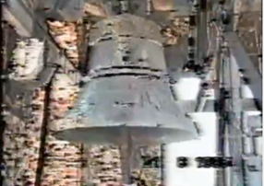

Figure 6: Chiesa di S. Geremia e Lucia Q1 video

To determine the quality of a video we implemented a rating system to include on the digital tag of the video.  The system ranges from Q1 to Q3: Q1 being completely unusable and Q3 is a video or potential audio which would be a good addition to our project. Figure 6 provides an example of an unstable video (Q1 rating).  The Q2 rating means that this video would only be used if access to the tower pertaining to it was not granted. This would be the case where we could not replace it with a better video of our own and would have to use the Q2 video that was available to us.  In addition to rating the quality of the videos, we reorganized them by the church that they were taken in. The 2004 project devised a system in which each church has its own code, and for consistency we organized these videos according to their system. Before, all the videos were organized by year but now they are organized by the specific church code. The newly sorted videos were then organized into folders named with the corresponding church code, and each video was renamed to include our quality rating.

Once in Venice, we explored Venipedia for information from past projects.  We also obtained any missing information at the Venice Project Center.  We proceeded to consolidate all the information, written, video, and pictures, into folders arranged by church code. This information created a strong base for the rest of our project.

## 3.2 Integrating New and Updating Old Information on the Bells and Bell Towers in Venice

Integrating new information about bells and their towers was decided to be our primary focus.  With this aim in mind, we used a table created by the project completed in 2004 which listed each church in Venice and when it was visited in the past to choose which bells to visit.  Examining the table, we determined approximately fifty bell towers which had never been visited by past projects for whatever reason.  This list was sent to Professor Carrera who attempted to gain access to these bell towers.

While we were prepared for the situation in which all of the bell towers we listed were not accessible, we were able to gain access to eight towers: San Aponal, San Bartolomeo, San Giobbe, San Giorgio Maggiore, San Giovanni Elemosinario, San Marco, Santa Maria Assunta di Torcello, and San Salvador. After we had mapped out where these bell towers are located in the map below, we created a plan to visit them based on accessibility and weather conditions. 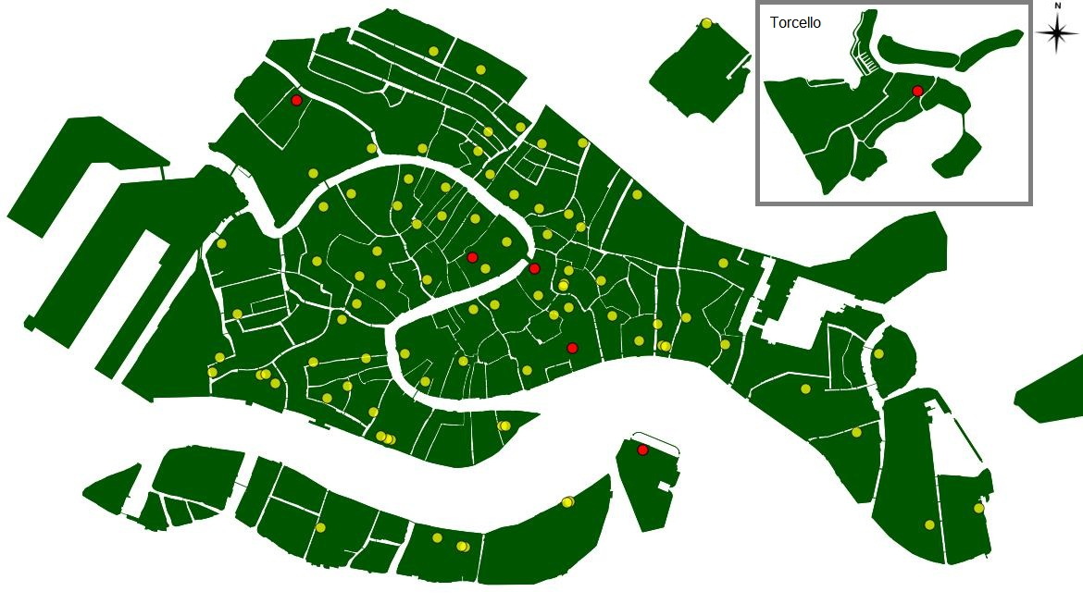

Figure 7: Map of Bell Towers in Venice

We started at San Giorgio Maggiore, since we knew that was open to the public and we could always revisit it if need be. We also went a second time, with Massimo, who restored the tower in 2004. This visit gave us many data that would not have been possible to collect otherwise. The tower is visitor friendly, meaning the stairs have been blocked off and now only an elevator is available to take visitors to the top. The bells are also hung extremely high in the belfry, too far for us to record any detailed observations. Massimo was integral to this visit as he allowed us to study the stairs leading to the top. He also played each of the bells from the digital wall unit from the bottom of the tower so we could record the ringing of each individual bell. Next was San Aponal, Torcello and San Giobbe, which we received access to from Paolo, who was working on major projects to restore these towers. San Aponal had not yet been visited by the Venice Project Center so we made some major contributions to the information for this tower. Our last bell tower visit was to San Marco, which was very similar to San Giorgio in that the stairs were not accessible and the bells were hung high. Although, we were unable to collect all the information the forms ask for, we did collect whatever information was possible for us.

Looking through past projects, we compiled a list of all of the data they had collected. We then added several fields of our own that we wanted to collect. The full list can be seen in Table 3 below.

|  |  |  |
| --- | --- | --- |
| Bell Data | Previous Projects | Our Project |
| Bell Height | X | X |
| Height from ground | X | X |
| Diameter | X | X |
| Age | X | X |
| Founder | X | X |
| Inscriptions | X | X |
| Location of inscriptions | X | X |
| Location in Venice | X | X |
| Safety/Accessibility |  | X |
| Restoration efforts | X | X |
| Art on bells (and location) |  | X |
| Type of Ringing | X | X |
| Time of bell ringing |  | X |
| Striking Note |  | X |
| Resounding pitches |  | X |
| Church (affiliation) | X | X |
| Material | X | X |
| Style of architecture | X | X |
| Owner/Affiliated Persons |  | X |
| Damage/Cracks | X | X |
| Condition of the Bell / Tower | X | X |
| History | X | X |
| Outside of Tower (clock/art) | X | X |
| Arrangement/Number of bells | X | X |
| Years monitored | X | X |
| Skid marks from clapper | X | X |
| Arches/Windows in Tower | X | X |
| Tower Danger | X |  |

Table 3: List of data collected by past projects compared to data we wish to obtain  
  
 In order to make the most of our visit, we divided up the many tasks that needed to be completed once inside the tower.  Also, having the same person perform the same tasks every time provides consistent data throughout the towers.  Janelle, whose camera was the best at taking close-up pictures, was responsible for chalking and taking pictures of the inscriptions and decorations on each bell as well as the entire bell.  She also filled out the General Bells and Frame Data Sheet.  Dani’s camera was the best at taking long distance photographs, so she was in charge of taking pictures of other bell towers as well as the facade and exterior of the tower.  Because she was most familiar with the sound recording equipment, she recorded the sounds of the bells. Dani also filled out the Technical Bells Data Sheet and took bell measurements with Madalyn. Rick was most familiar with the video recording equipment so was responsible for taking video of the bells ringing and of the view from the tower. He was also responsible for the three Internal Bell Tower Data Sheets. Since Madalyn had an accurate compass, she was responsible for taking the bearing of the front wall. She also counted the steps between each landing, took bell measurements with Dani, and filled out the Bells Inscriptions and Decorations Data Sheet. Whichever team member finished first was then responsible for the External Bell Tower Data Sheet. This person varied depending on how long each task took in a particular tower.

After identifying which bell towers had little to no data from past IQP projects, we set out to remedy this knowledge gap. Many of the towers remained inaccessible despite our best efforts to gain access to them. However, we were able to collect data on many of the bells and bell towers during our time in Venice. The two most critical tools used in updating the data were the Tascam audio recorder and the GoPro video recorder. Over the course of our project, we acquired # audio recordings, # video recordings, as well as # photos. We visited five towers, Saint Aponal, Torcello, San Giobbe, San Giorgio, and San Marco. Saint Aponal had not yet been visited and, although the others had been visited full sets of data had not been collected on each using our new update technology.

### 3.2.1 Video Capture

To capture video from the top of the tower, we used a GoPro video camera. We began with the camera pointing north and panned clockwise until reaching north again. This gave us a 360° view from the top of the towers we visited. We also used the camera to pan around each of the bells so we would have a unique view of the bell from every angle. If there happened to be a scheduled ringing of the bells while we were in the tower, we were able to film a bell or a few bells ringing automatically, either by wheel or hammer. Afterwards, we were able to edit some of these videos using simply windows movie maker to cut out any unnecessary images or sound that happened to be captured.

### 3.2.2 Audio Capture

While in Venice, we used a DR-40 Linear PCM Recorder[65] to capture audio of each of the bells ringing. This gave us the sound of all of the bells ringing in their usual pattern. We then used a program called Audacity to analyze the signal and identify the note that each bell tolls at. One can do this by zooming into the moment in the audio when the bell is first struck and highlighting that part. Then, we analyzed the plot spectrum of the highlighted section and retrieved the frequency at the highest peak in the spectrum. Using this frequency, one can look up the musical note that it correlates to. In several cases, we were unable to record the sound of individual bells and instead recorded the sound of multiple bells in the tower ringing. Using the audacity software, we were sometimes able to cut the audio track so only one bell would be rung. Another, positive aspect of the software is the noise removal tool which can be very helpful in removing wind, voices, or any other background noise from the sound clip.

## 3.3 Distributing Collected Bell Data to the Public

One of the major goals we have accomplished in completing this project was to begin to make all the data on bell towers in Venice that both our project and previous projects have collected available to the public. No group before us has been able to do this. We have two outlets for users to view our data: Venipedia and the Venice Bells Website. We contributed to Venipedia, the wiki resource supported by the Venice Project Center, by making 3 different types of pages to give the user a comprehensive understanding of the bells of Venice. Also, we created a website specifically for our project that provides additional information, as well as interactive maps and applications. These each provide information, maps, and media to anyone interested.

### 3.3.1 Venipedia

When the information in Table 3 was collected, it was incorporated into the Venipedia website, where new pages were created.  With the guidance of the Venipedia team we developed several types of wikipages: Bell Towers (plural), Bell Tower (singular), Bells (plural), Bell (singular), and individual pages for both the bell towers and the bells.  Each page serves the ultimate purpose of organizing all of our data in a public and logical way.

The plural pages give an overview of all of the bells or bell towers in Venice. These pages include statistical information such as how many there are, where they are located, and what condition they are in. They also include links to all of the individual pages discussed below. The singular pages refer to general information that can be said about all of the bells or bell towers in Venice.  We based most of the information of the bell tower page on the existing page in Venipedia and drew heavily from the background chapter of this report.  Information on the two types of pages covers a general definition or overview about the two topics and their original purposes throughout history.  Interactive maps indicating all of the bells’ and bell towers’ locations in Venice will also be a component on both pages.

    The individual pages cover, as suggested by their title, information about individual bells and bell towers.  Key information for each bell tower page includes age, architecture type, dimensions, rate of safety, accessibility to the public, video of the view at the top of the tower, location on a map of Venice, owner or persons in charge (either of bell tower or of the church), and pictures of the bell tower. For the individual bell pages pertinent data includes pitch of each bell, material used to cast the bell, picture of the bell, documentation of artwork or inscription on bell, manual or mechanical ringing, at what time of day it rings, and video and audio of the bell ringing.  
    Links to other pages within the Venipedia site will have been incorporated appropriately on each page.  The individual bell pages include links to their corresponding bell tower page, and the individual bell tower pages include links to both the church they are affiliated with and the individual bell pages.  The plural pages for each category will link to all of the individual pages.

Once we had organized all of the data on bells and bell towers, we created Venipedia pages to make it accessible to the public. The singular and plural pages for Bell(s) and Bell Tower(s) were created manually, as was the Bell Swinging page. The Bell and Bell Tower pages create an overview of a typical example of each. The two plural pages include statistical analyses of much of the bell and bell tower data. The Bell Swinging page was created using information from our background section. Originally, this was supposed to be a sub-section on the Bell page. However, it is information that could need to be accessed from multiple pages. Also, we have a lot of information on that subject and so decided to create a separate page for it.

We also generated ### individual Bell Tower pages and ### individual Bell pages. We incorporated all of the data that past teams have collected into these pages. We used the various field forms in order to design the layout of the pages. The Bell Tower pages are a combination of the Tower Interior and Tower Exterior forms, while the Bell pages take their data from the series of Bell Data forms. Much of the general church information that was collected was not included on our pages and was instead incorporated into the individual Church pages. Unfortunately, not all of the data sets are complete, so some individual pages contain little to no information beyond the name.

### 3.3.2 Website

For a main component of our project we created a website called venicebells.com.  A main part of this website was that it would provide users easy access to all of the information in our database for the project, as described in section [3.1.2](https://docs.google.com/document/d/1NsCXynM6Sb4yLkV--nlEv5hgxCy1AtnMvyJuypwQ3qk/edit#bookmark=id.d7mdp6xwrtx) of this report.  
 On the main page of the website, there is an interactive map that allows users to visually experience the ringing times of the Venetian bells. While bells are ringing in real time they are also highlighted on a map.  There are time and day sliders so the user can navigate to a specific day and time to see which bells ring and where they ring.

### 3.3.3 Smartphones

Mobile communications have been spreading across the globe since they were first introduced. Today, there are over 4 billion people with mobile subscriptions.[66] Of these mobile subscribers, an ever-increasing number own smartphones. As defined by Encyclopædia Britannica, a smartphone is:

“a mobile telephone with a display screen, built-in personal information management programs, and an operating system (OS) that allows other computer software to be installed for Web browsing, e-mail, music, video, and other applications.”[67]

The introduction of the smartphone brought around many changes. From day-to-day tasks to company business, smartphones have become a vital tool to their owners. They provide access to a wealth of information anytime and anywhere. Smartphones are “not only changing the way we communicate; they are going to change the way we access information,”[68] just as laptops did when they first premiered. As networks improve and smartphones are becoming as good if not better at accessing information than computers, more and more people are turning to their smartphones for their information needs.

The cause of this trend towards mobility can be traced back to several key technological advances in recent years. Increased bandwidth, powerful operating systems, expandable memory, screen design, longer lasting batteries, and location-aware searching all aided the rise of smartphones.[69]  These devices have had a boom of popularity, and are expected to increase 500% over the next four years.[70]

### 3.3.4 PreserVenice Venice Public Art App

The goal of our mobile application is to be a portable source of information that will provide its users with a fun way to learn about and tour through Venetian bell towers.

Through providing users with our application we hope to accomplish our objective of inspiring appreciation for the bells and bell towers of Venice.

# 4.0 BELLS OF VENICE

The conclusions made from data collected by us and previous research tell us about the conditions of the bells, what aspects they have in common, and important facts such as age, number, and size. By examining the data collected thus far, we can better generalize the information on the all bells in Venice and look for trends or similarities that they may have in common. This will provide us with a better idea of strategies used for deciding what and how many bells are required and may also help us predict when restoration is needed.

## 4.1 Bell Sizes

Venice has 203 bells spread throughout the city. The largest bell documented is bell 2 of Sant’ Elena with a diameter of 152 cm, and the smallest bell documented is bell 4 of San Nicolò dei Mendicoli with a diameter of 21 cm.

From the graph above, it can be determined that the most frequent size for the diameter of a bell is from 80 to 99 cm.. Ironically, the shape of the graph resembles a bell curve. The average ratio of diameter to internal bell height is 1.22 cm with a standard deviation of .106 cm. Therefore, the size of the bells may vary, but the shape is similar for all bells in the city.

## 4.2 Ringing Methods

The ringing method is the same for most bells in the city of Venice. Hammer and wheel are the primary types of ringing. However, wheel is most common, as 87% of the bells in Venice are rung by wheel. The second most common, are bells rung by both wheel and hammer, which is 12%. The graph below gives an idea of the popularity of these ringing mechanisms for the bells of Venice:

## 4.3 Bell Condition

Because we believe bells to be an integral part of the material culture of Venice, it’s important to track the conditions of bells so it is possible to determine when and how much renovation is needed. As discussed before, the materials that they are made from, although durable, are still vulnerable to chipping and cracking, discoloration, and rust. Our team and past teams have rated these criteria on a scale of 0 to 4: 0 meaning there is no need for restoration and 4 meaning that restoration is urgent.

The majority of the bells measured thus far have had a conditional rating of 1 for both cleanliness and discoloration. This means that there is some, but not a problematic amount. Rust had a slightly higher common rating of 2 which still is not very problematic. The ones that need restoration should have rating of 4 for each category. Luckily, there are 5 or less bells for each of the categories that had ratings of a 4. There seems to be little correlation between the three categories. Where there seems to be a great number of bells with a certain rating for one category, there may only be a few rated the same for a different category. Perhaps, when considering a bell for restoration, one may only have to confront one problem. However, from our data we found some bells with a rating of 4 in all categories, such as those in the bell tower of San Silvestro. Future groups may want to revisit the tower to determine if restoration is needed.

# 5.0 BELL TOWERS OF VENICE

While in Venice we were only able to visit four bell towers, which isn’t nearly enough to make assumptions about all of the towers. However, since the first project team in 1992, the Venice Project Center has collected at least some data on ### of the ### bell towers in Venice. While each tower does not have a complete set of data we can still look at the fields that we have information for.

## 5.1 Sestiere

Castello is the sestiere with the most bell towers at 18, while Burano, with only one tower, has the least. Technically speaking, there are several islands that have no bell tower at all, but of the islands that have bell towers, Burano has the least. Below is a graph showing the percentage of bell towers in each sestiere.

As would be expected, the highest number of bell towers can be found on the main islands of Venice, particularly in Castello, Cannaregio, and Dorsuduro. The sestiere of Giudecca and Murano have almost as many bell towers as the main island districts of San Polo and Santa Croce. As is expected, the outlying islands have the lowest number of bell towers. Presumably the areas with a higher concentration of churches are in the areas with a higher population density.

## 5.2 Height

The shortest tower, Santa Eufemia, is only 10m tall. The tallest tower is San Marco, at a whopping 98m in height. Below is a graph of the various tower heights.

The majority of towers are between 40 and 70 meters tall. For a bell tower this makes sense because the ultimate goal is to be able to hear the bells from some distance away. Between 0 and 40 meters the sound would get obstructed by surrounding buildings and wouldn’t travel very far. However, go too high and the sound has farther to travel and will dissipate considerably before reaching the ground. There is also a significant number of towers between 20 and 30m tall. Most of these are older towers, suggesting that they were built as high as possible for that time period.

## 5.3 Bells per Tower

The tower of San Giorgio di Maggiore has 9 bells, the most in the city. With only two bells, Santa Maria di Nazateth Scalzi has the least. Once again, there are towers with no bells, but those are not included in the count. A graph with the number of bells in each tower is below.

Interestingly enough, the number of bells per tower forms an approximate bell curve peaking at 4. The reason for that is most likely musical. Three notes create a chord. In most cases, changing only one note in the chord can produce an entirely different sound. While three bells can produce one chord, having four means the tower can ring four different chords by changing which bell is silent. Another possibility is the size and shape of the belfry. Many of the towers have square belfries. Bell hangings are large and cumbersome, so having more than one per side may not be possible in some cases.

# 6.0 RECOMMENDATIONS

One of our major accomplishments was preparing the data, media, and Venipedia pages for future students to use and improve upon. Time constraints, however, restricted the amount we could achieve. From our work in Venice, we came up with a few suggestions along the way for potential deliverables that future project center groups might find helpful.

## 6.1 Visiting Towers and Data Collection

Gaining access to towers over the course of our project proved to be very difficult, as many are worried about the liability and the safety of allowing students into the towers. We hope that our work this term will prove to those granting access that WPI students are both professional and dedicated to studying the bells of Venice. Although, future groups should plan on visiting about three to six towers while in Venice.

However, we believe that there is a lot of work to be done even without access to the towers. There is external data missing for at least 57 towers. Groups should definitely consider taking trips to these towers and collecting what they can even without interior access. Another contribution students can make without having access to the towers, is cataloguing when the bells ring. This can be difficult because most times, not even the priests know when they are rung. Some ways this can be done, are by word of mouth or going to towers on the hour or half hour. This is something that we worked to do this term but could not finish. However, this information can still contribute to the map discussed earlier, found at bells.veniceprojectcenter.org. All that is needed is for the data to be input into the coding.

## 6.1 Alter Data Collection Forms

When visiting the towers, we collected data using the forms from past projects. However, it became clear that a few of these forms were no longer necessary. For instance, one of the forms had to do with describing each photo taken and labeling it with which roll of film it was taken on. Graphics and audio from each instrument were stored on their own respective SD cards so there was no need to keep track rolls of film. For pictures taken of each bell, there was a preceding photo in which we showed the bell number with our fingers. If it was necessary to also catalog the side it was taken on, we started from the front side and then took consecutive pictures in a clockwise direction, so we knew which side each picture was taken from. There was an additional form for collecting photos and videos which had a large box with each side labeled front, left, right, back. We also neglected to use this sheet because we did not find it to be very intuitive or easily understandable.

As for future groups collecting data in the towers, we would recommend altering the forms based on the data already available from previous projects. There has already been quite a lot of information collected. If the group is only revisiting a bell tower, they may want to use a second type of form that is shorter, and only tries to fill in gaps where there is no information or where information is not as accurate. This would save the group a lot of time and give them more time to update the media on the tower with photo, video, and audio recordings.

## 6.3 A New Database

In the past, groups have used a Microsoft Access database to organize their data. We took all the information in that database and transferred it to a Microsoft Excel spreadsheet, which helped make CSV files for automated Venipedia pages. One of the problems we found with Microsoft Access was that information could be lost with broken links. Futures groups may consider making a mySQL database so that all the information can be kept in one place, information can be added easily, and CSV files can be made.

## 6.4 Mobile Application

One deliverable for our project was to add on to the Venice Public Art application sponsored by UNESCO. However, another possibility would be to make a mobile application specifically for the bells and bell towers of Venice. It could be a source of information as well as a tool for collecting information. It may have some similar functions as the Venice public art application such as a map that links to data on the bells. However, there could also be a function for users to help with data collection, whether it is taking pictures and videos, or recording the ringing of the bells. These would make a great addition to our website which could hold a gallery of the pictures and media taken of or at different bell towers. Another possible function for the application could be a Shazam-like feature that would tell you what bell or bell tower is ringing. However, because bells sound so similar, instead the app might be able to determine this by using location and the radius of sound of the bells playing.

## 6.5 Financial Analysis

People have stopped caring about the bells in Venice because they cannot physically climb up to the top and see all of the bells and the views of Venice.  A future goal would be to help the churches associated with these bells obtain more funding for the maintenance of their bell towers.  It would be interesting to determine whether it is economically beneficial for the churches if people were allowed access to the bell towers.  Future groups may also want to determine whether churches could potentially renovate their bell towers using the income gained by giving access to the public. The information collected by our project and the projects before us could be put to use by the churches and the people visiting the towers.

To accomplish this goal, we would recommend contacting the people who oversee the bell towers at San Marco and San Giorgio Maggiore. From there, you may be able to obtain information concerning the costs incurred to renovate and the operating costs to run the tower as well as income from visitors. One of the potential downfalls of opening another tower could be location. If a church is off the beaten path, not many people will visit. Another negative may be that churches do not want all these tourists to visit or that they would need to have someone to guide tours up to the towers. However, one of the biggest concerns of the churches that we know of is that the towers are not safe. For some, climbing up the towers is dangerous and for others, the belfries are not sanitary. The church may have to invest in repairing the towers to remove these safety concerns before allowing people to go up into them.

To accomplish the task of giving people access to the towers, we would recommend proposing to the priests of several churches a plan to provide access for a fee to those who want to go and see the bells up close.  From this fee the churches may then save money for renovations from the crowds of tourists who visit Venice each year as well as from history and art enthusiasts who would have never had the chance to see the Venetian church bells until now.

## 6.6 Sound Analysis

An integral part of our project was introducing the use of the Tascam recorder in our data to provide high quality sounds of the bells. After taking these recordings, we determined the musical note of the bell when it is first struck. However, once there is enough data, it would be interesting to find any trends in the musicality of the bells. For instance, one could analyze if there are common chords that the bells may make when played together because most towers have three to four bells.

It may also be useful to determine the radius in which the bells can be heard, which can be determined mathematically but one should also account for sound reverberating off of buildings. This may help with creating a mobile application that would help someone determine what tower they are hearing bells ringing from by analyzing the distance away from the tower.

# 5.0 Conclusion

Over the past seven weeks, we have worked to increase our knowledge of bells and bell towers and the past projects that have studied them. We have immersed ourselves into the project by brainstorming ideas to achieve our mission, designing our website and application, making infographics, and planning out how we will collect data while in the bell towers. This proposal is a culmination of our work this past term and will be a guide for our project in Venice. Bells are not only important to us, but are also critical to the history and culture of Venice. By achieving the objectives described above, we hope to preserve the bells as a part of material culture by reconnecting the public with the bells of Venice.

# 5.0 BIBLIOGRAPHY

*Bell* Encyclopædia Britannica Inc, 2012.

*Church Bells: Their Uses, their Romance, and their History*. England: 1903.

*Disaster Management Programs for Historic Sites*. United States: 1998.

"ICOMOS Charter for the Interpretation and Presentation of Cultural Heritage Sites." *International Journal of Cultural Property* 15, no. 4 (2008): 377-383. doi:10.1017/S0940739108080417.

"The International Charter for the Conservation and Restoration of Monuments and Sites (Venice Charter)." *APT Bulletin* 37, no. 4 (2006): 51-51.

"Italy: Venice Silences its Church Bells." *McClatchy - Tribune Business News,* Jun 8, 2012, 2012. <http://search.proquest.com/docview/1019230554?accountid=29120>.

"Verdin: Bells and Clocks since 1842." The Verdin Company, accessed 09/30, 2012, [www.verdin.com](http://www.verdin.com/).

"World Heritage." UNESCO, accessed 09/09, 2012, [http://whc.unesco.org](http://whc.unesco.org/).

Agger, B. "ITime: Labor and Life in a Smartphone Era." *Time & Society* 20, no. 1 (2011): 119-136.

Ammerman, Albert J. and Charles E. McClennen. "Saving Venice." *Science* 289, no. 5483 (2000): 1301-1302.

Angeloni, Paolo, P. P. Rossi, and M. Vavassori. "Monumental Restorations." *Civil Engineering* 67, no. 2 (1997): 36.

Anonymous. "Saving the Art of Church Bell-Ringing: Garage Music." *The Daily Telegraph,* 2011.

Babyak, Richard. "Reinventing the Bell Tower." *Appliance Design* 53, no. 3 (2005): 5.

Baca, Murtha.*Cataloging Cultural Objects: A Guide to Describing Cultural Works and their Images*, edited by Baca, Murtha ALA Editions, 2006.

Ball, Dr Steven*. The Defense of Bells: Their use and History in the Roman Liturgy*.

Beconcini, M. L., S. Bennati, and W. Salvatore. "Structural Characterization of a Medieval Bell Tower: First Historical, Experimental and Numerical Investigations." *University of Pisa, Dept. of Structural Engineering, Pisa, Italy* (2001).

Beros, Suman, Marian K. Riedy, and H. J. Wen. "Managing Business Smartphone Data." 14, no. 9 (03; 2012/9, 2011): 3. <http://go.galegroup.com.ezproxy.wpi.edu/ps/i.do?id=GALE%7CA251277646&v=2.1&u=mlin_c_worpoly&it=r&p=ITOF&sw=w>.

Carbognin, Laura, Pietro Teatini, Alberto Tomasin, and Luigi Tosi. "Global Change and Relative Sea Level Rise at Venice: What Impact in Term of Flooding." *Climate Dynamics* 35, no. 6 (2010): 1039-1047. doi:10.1007/s00382-009-0617-5.

Carrera, F. "What Cultural Heritage do we Preserve and Why." (1997).

Carrera, F. and J. Cocola. "Venipedia."

Carrera, Fabio. "CITY KNOWLEDGE: An Emergent Information Infrastructure for Sustainable Urban Maintenance, Management and Planning." PhD dissertation, MIT, 2004.

Choo, Hyungseung and Dong-Hee Shin. "Exploring Cross-Cultural Value Structures with Smartphones." 20, no. 2 (April; 2012/9, 2012): 67. <http://go.galegroup.com.ezproxy.wpi.edu/ps/i.do?id=GALE%7CA294897648&v=2.1&u=mlin_c_worpoly&it=r&p=ITOF&sw=w>.

Cloonan, Michèle Valerie. "The Paradox of Preservation." *Library Trends* 56, no. 1 (2007): 133-147.

Costa, Virginia and Annick Texier. "Restoration of Cultural Heritage: Evaluation of the Compatibility between Metals and Sealing Products." *Journal of Solid State Electrochemistry* 14, no. 3 (2010): 403-405. doi:10.1007/s10008-009-0891-5.

Cotton, Jeff. "The Churches of Venice." , accessed Sept. 09, 2012, <http://www.churchesofvenice.co.uk/sanmarco.htm#sanbart>.

D’Ambrisi, Angelo, Valentina Mariani, and Marco Mezzi. "Seismic Assessment of a Historical Masonry Tower with Nonlinear Static and Dynamic Analyses Tuned on Ambient Vibration Tests." *Engineering Structures* 36, (2012): 210-219. doi:10.1016/j.engstruct.2011.12.009.

de Oliveira, F. J. R., D. C. B. Lago, L. F. Senna, L. R. M. de Miranda, and E. D’Elia. "Study of Patina Formation on Bronze Specimens." *Materials Chemistry and Physics* 115, no. 2 (2009): 761-770. doi:10.1016/j.matchemphys.2009.02.035.

DeVoto, Mark. "Boris's Bells, by Way of Schubert and Others." *Current Musicology* no. 83 (2007): 131-152.

Entertainment, Shazam.*Shazam* 2002.

Ericsson. "Interim Traffic and Market Data Report Covers Growth in Subscriptions, Voice Traffic and Mobile Data." , accessed September 9, 2012, <http://www.ericsson.com/news/120222_interim_traffic_and_market_data_report_covers_growth_in_subscriptions_voice_traffic_and_mobile_data_244159020_c>.

Fitzgerald, K. P., J. Nairn, and A. Atrens. "The Chemistry of Copper Patination." *Corrosion Science* 40, no. 12 (1998): 2029-2050. doi:10.1016/S0010-938X(98)00093-6.

Freemantle, Michael. "Safeguarding Venice." *Chemical & Engineering News* 78, no. 35 (2000): 23.

Gatty, Alfred and Universal Library.*Bell its Origin History and Uses* George Bell, 1848.

Gentile, C. and A. Saisi. "Ambient Vibration Testing of Historic Masonry Towers for Structural Identification and Damage Assessment." *Construction and Building Materials* 21, no. 6 (6, 2007): 1311-1321. doi:10.1016/j.conbuildmat.2006.01.007.

Google. "Android Developers.", accessed September, 10, 2012, <http://developer.android.com/index.html>.

Gromort, Georges.*Italian Renaissance Architecture*. England: 1922.

Hamilton, Donny L.*Methods for Conserving Archaeological Material from Underwater Sites*. Texas A&M University: Department of Anthropology, 1998.

Hassler, S. "Our Smartphones, Ourselves." *Spectrum, IEEE* 49, no. 9 (2012): 10-10.

Hedberg, Yolanda. "Protective Green Patinas on Copper in Outdoor Constructions." *Journal of Environmental Protection* 2, no. 7 (2011): 956-959. doi:10.4236/jep.2011.27109.

Heike C Alberts and Helen D Hazen. "MAINTAINING AUTHENTICITY AND INTEGRITY AT CULTURAL WORLD HERITAGE SITES." *Geographical Review* 100, no. 1 (2010): 56.

Ibelings, Hans. "Italian Architecture from the Outside in." *Architectural Design* 77, no. 3 (2007): 104-105. doi:10.1002/ad.465.

Inc., AmeriClock. "Church Bell Ringing & Bell Strikers." , accessed Oct. 09, 2012, <http://www.usbellco.com/bell-strikers/>.

Ivorra, Salvador and Jose Ramon Cervera*. Analysis of the Dynamic Actions when Bells are Swinging on the Bell-Tower of Bonrepos i Mirambell Church (Valencia, Spain)*. Guimarães: Historical Constructions, P.B. Lourenço, P. Roca (Eds.), 2001.

Ivorra, Salvador and Francisco J. Pallarés. "Dynamic Investigations on a Masonry Bell Tower." *Engineering Structures* 28, no. 5 (2006): 660-667. doi:10.1016/j.engstruct.2005.09.019.

Ivorra, Salvador, María José Palomo, Gumersindo Verdú, and Alberto Zasso. "Dynamic Forces Produced by Swinging Bells." *Meccanica* 41, no. 1 (2006): 47-62. doi:10.1007/s11012-005-7973-y.

Knopf, Alfred A.*Venice*, edited by Knopf Guides Knopf Guides, 1993.

Lamei, Saleh. "Insights into Current Conservation Practices." *Museum International* 57, no. 1‐2 (2005): 136-141. doi:10.1111/j.1468-0033.2005.00522.x.

Lamont, A. C. and N. J. London. "Bell Ringers' Bruises and Broken Bones: Capers and Crises in Campanology." *BMJ (Clinical Research Ed.)* 301, no. 6766 (1990): 1415-1418.

Lane, Wilburn and Chris Manner. "The Impact of Personality Traits on Smartphone Ownership and use." *International Journal of Business and Social Science* 2, (09/15; 2012/9, 2011): 22. <http://go.galegroup.com.ezproxy.wpi.edu/ps/i.do?id=GALE%7CA285886531&v=2.1&u=mlin_c_worpoly&it=r&p=AONE&sw=w>.

Lima,Nicholas Alexander Student author -- ME, Kazanovicz,Christopher John Student author -- MGE, Fitzgibbon,Jonathan James Student author -- BE, Rosales,Courtney Anne Student author -- BE, Carrera,Fabio Faculty advisor -- ID, and Bianchi,Frederick W.Faculty advisor -- HU.*PreserVenice -- Preserving the Material Culture of Venice*. Worcester, MA: Worcester Polytechnic Institute, 2012.

Lin, P. Paul and Kevin F. Brown. "Smartphones Provide New Capabilities for Mobile Professionals." *The CPA Journal* 77, no. 5 (May 2007, 2007): 66-71. <http://search.proquest.com/docview/212232170?accountid=29120>.

Marion, M. *Preservation of Venetian Bell Towers* (2004).

Monclús, F. J., Manuel Guàrdia i Bassols, and Ebrary Academic Complete.*Culture, Urbanism and Planning*. Burlington, VT: Ashgate, 2006.

Mukhanov,Sofia Student author -- BE, DeZulueta,Elizabeth Marie Student author -- RBE, Avila,Corrie Elizabeth Student author -- ME, Sokk,Maarja-Liisa Student author -- MAC, Carrera,Fabio Faculty advisor -- ID, and Cocola,James Faculty advisor -- HU.*Exploring the History of Venice -- Relics, Records, and Relations*. Worcester, MA: Worcester Polytechnic Institute, 2011.

Neithercut,Scott James Student author -- CE, Messier,Paul Francis Student author -- ECE, Leenhouts,Douglas Jacob Student author -- MIS, Carrera,Fabio Faculty advisor -- ID, and Salazar,Guillermo F.Faculty advisor -- CE.*The Sounds of Venice -- Appendices* 2003.

Nosengo, Nicola. "Venice Floods SAVE OUR CITY." *Nature* 424, no. 6949 (2003): 608-609. doi:10.1038/424608a.

Perry, Claudia A. "Education for Digitization: How do we Prepare?" *The Journal of Academic Librarianship* 31, no. 6 (11, 2005): 523-532. doi:10.1016/j.acalib.2005.08.004.

Pertot, Gianfranco.*Venice: Extraordinary Maintenance*. London: Paul Holberton, 2004.

Randolph Starn. "Authenticity and Historic Preservation: Towards an Authentic History." *History of the Human Sciences* 15, no. 1 (2002): 1-16. doi:10.1177/0952695102015001070.

Russo, G., O. Bergamo, L. Damiani, and D. Lugato. "Experimental Analysis of the “Saint Andrea” Masonry Bell Tower in Venice. A New Method for the Determination of “Tower Global Young’s Modulus E”." *Engineering Structures* 32, no. 2 (2, 2010): 353-360. doi:10.1016/j.engstruct.2009.08.002.

Scott, David A. "Bronze Disease: A Review of some Chemical Problems and the Role of Relative Humidity." *Journal of the American Institute for Conservation* 29, no. 2 (1990): 193-206.

Smith, Abby. "Valuing Preservation." *Library Trends* 56, no. 1 (2007): 4-25.

———. "Why Digitize?" *Microform and Imaging Review* 28, no. 4 (1999): 110-18.

Spennemann, Dirk H. R. "Cultural Heritage Conservation during Emergency Management: Luxury Or Necessity?" *International Journal of Public Administration* 22, no. 5 (1999): 745-804. doi:10.1080/01900699908525403.

Strafford, K. N., R. Newell, J. Audy, and K. Audy. "Analysis of Bell Material from the Middle Ages to the Recent Time." *Endeavour* 20, no. 1 (1996): 22-27. doi:10.1016/0160-9327(96)10003-X.

Tascam. "Handheld 4-Track Recorder: Giving You Flexibility Needed to Record Anywhere." , accessed October 2, 2012, <http://tascam.com/product/dr-40/>.

Thomollari, Orest Student author -- CE, Schmaelzle,Matthew J.Student author -- CS, Ratner,Gregory I.Student author -- CS, Kelley,Aaron Edward.Student author -- ME, Fabio Faculty advisor -- ID Carrera, and H. J. Faculty advisor -- HU Manzari.*Public Art Preservation in Venice: Non-Public Wellheads and Fountains* 2004.

Tyack, Geo S. (George Smith). *A Book about Bells / by the Rev. Geo. S. Tyack* 1898.

Viklund, Andreas. "Bronze Bells." Central Council of Church Bell Ringers, accessed 10/9, 2012, <http://cccbr.org.uk/pr/publicity/bellsandbellringing/>.

Vitone,Christopher Edward.Student author -- CS, Mill,Eric Rogers.Student author -- CS, Michael Student author -- CS Milkin, Marion,Melissa W.Student author -- ECE, H. J. Faculty advisor -- HU Manzari, and Carrera,Fabio Faculty advisor -- ID.*Preservation of Venetian Bell Towers* 2004.

Wade,Julie Anne Student author -- MA, Nunez,Gabriela C.Student author -- EVS, Brown,Jeremy Scott Student author -- BE, Aragon,Lorey Michelle Student author -- IE, Bianchi,Frederick W.Faculty advisor -- HU, and Carrera,Fabio Faculty advisor -- ID.*Digitizing the Archives of the Private Committees for the Safeguarding of Venice*. Worcester, MA: Worcester Polytechnic Institute, 2012.

Walters, Henry Beauchamp.*Church BellsVolume 2 of Arts of the Church* A. R. Mowbray & Company, 1908.

White, M. "Information Anywhere, any when: The Role of the Smartphone." *Business Information Review* 27, no. 4 (2010): 242-247.

William L. Hosch.*Smartphone* Encyclopædia Britannica Inc, 2012.

# Appendix A: Budget

**Our Current Budget: $300.00**

|  |  |  |  |  |
| --- | --- | --- | --- | --- |
| **Item** | **Cost** | **Number of Items** | **Supplier/**  **Model** | **Total Price** |
| Ear Protection | $16.77 | 4 | Home Depot/3M Tekk Protection Red Shotgunner Earmuff | $67.08 |
| Eye Protection | $2.97 | 4 | Home Depot/3M Tekk Protection Clear Eye Protector Safety Glasses | $11.88 |
| Face Masks | $19.97 | 2 | Home Depot/3M Tekk Protection Respirators (20-Pack) | $39.94 |
| Gloves | $1.97 | 4 | Home Depot/Firm Grip Suede Cowhide Leather and Denim Large Work Gloves | $7.88 |
| Chalk | $4.69 | 1 | Office Depot/Quartet® Alphasite™ Triple-Size Chalk, 3 1/4"L x 5/8"D, Box Of 12 | $4.69 |
| Flashlight | $9.00 | 2 | Google Shopping/Nebo Tools Nebo 5077 CSI Tactical LED Flashlight with Laser | $18.00 |
| Camera | n/a | 2 | ATC/Venice Project Center | n/a |
| SD Card | $9.99 | 1 | Radioshack/SanDisk® 8GB SDHC™ Memory Card | $9.99 |
| Wireless Attachement for GoPro | $59.99 | 1 | GoPro/ WiFi BacPac | $59.99 |

**Total Cost: $219.23**

# Appendix B: Venipedia Templates

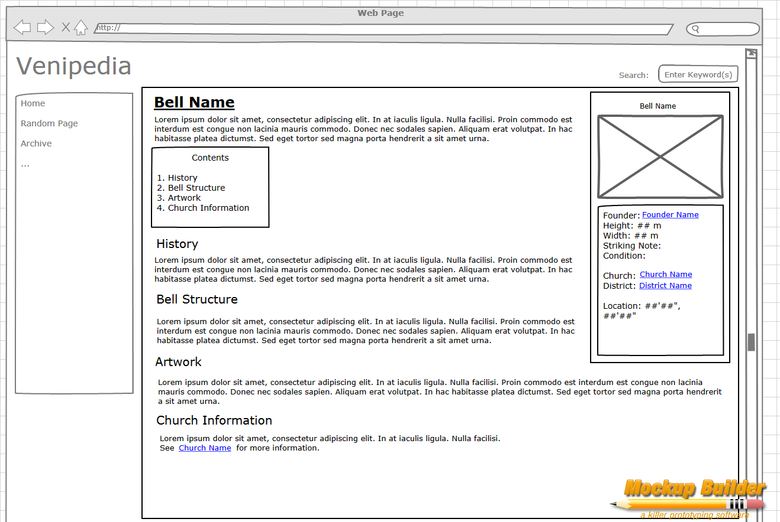

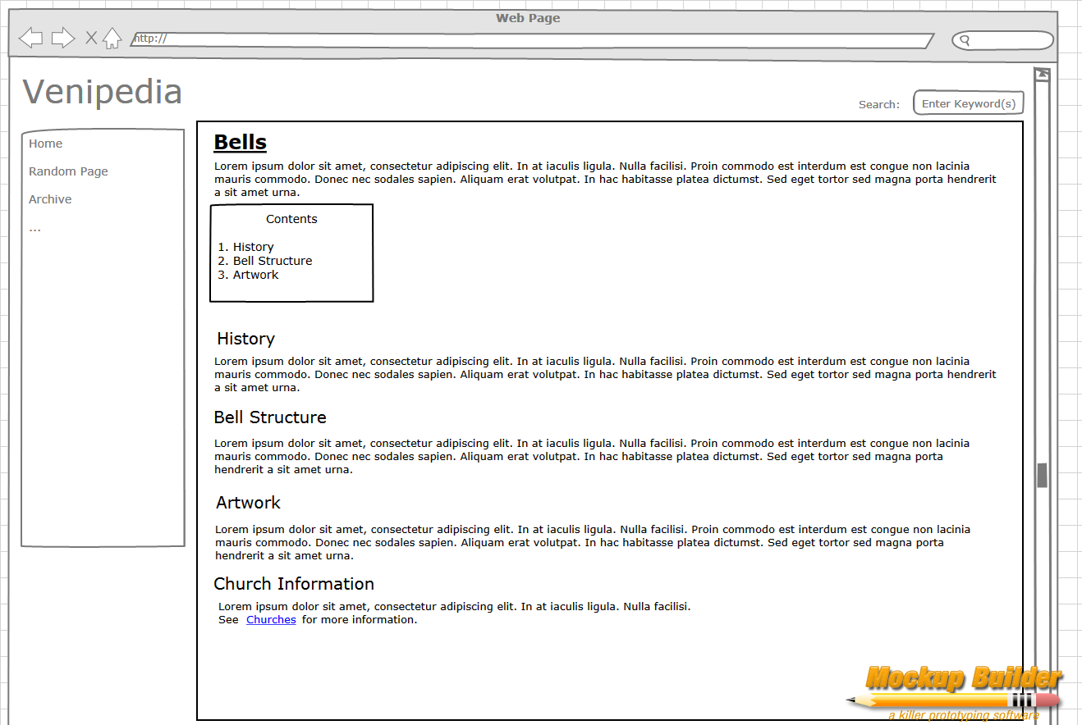

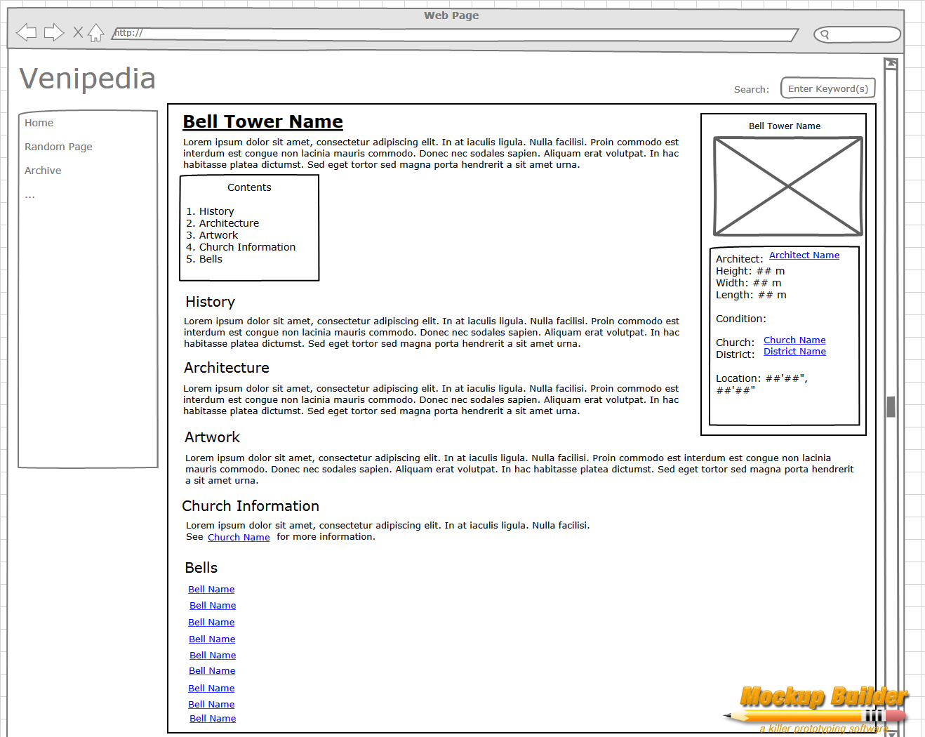

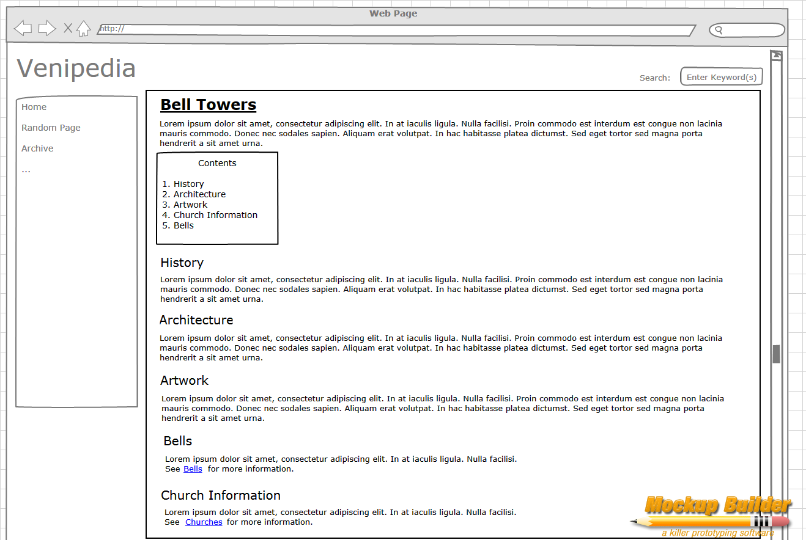

# Appendix C: Field Forms

The following set of forms was created by the 2004 Bells IQP group. This set is meant to also be used as a stand alone guide that should be printed out on its own and carried by any group to any bell tower that they are visually monitoring. 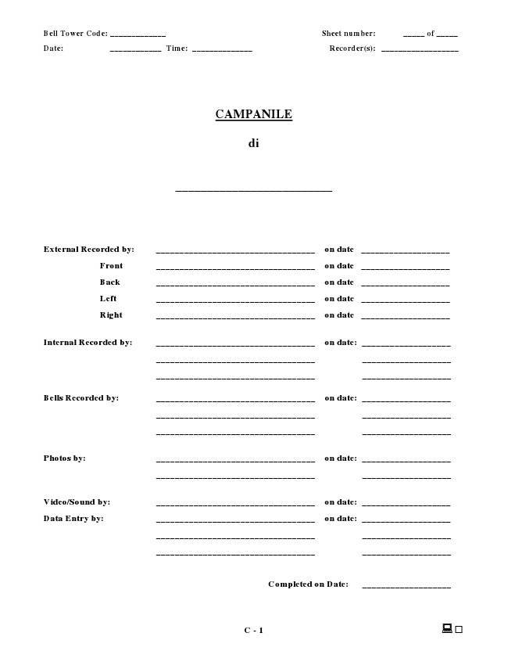

**Bell Tower Code: _____________ Sheet number: _____ of _____**

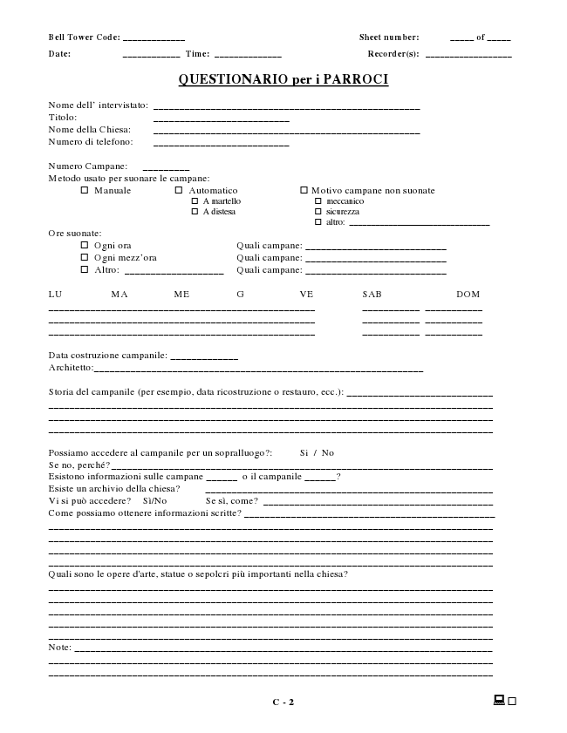

**Bell Tower Code: _____________ Sheet number: _____ of _____**

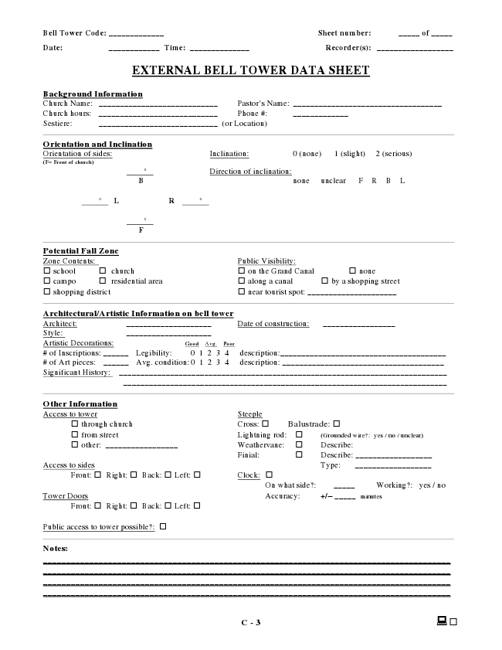

**Bell Tower Code: _____________ Sheet number: _____ of _____**

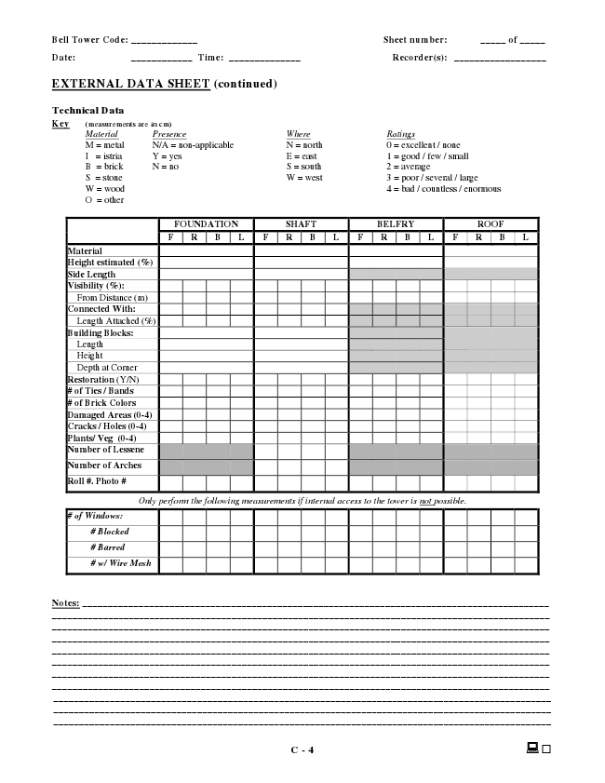

**Bell Tower Code: _____________ Sheet number: _____ of _____**

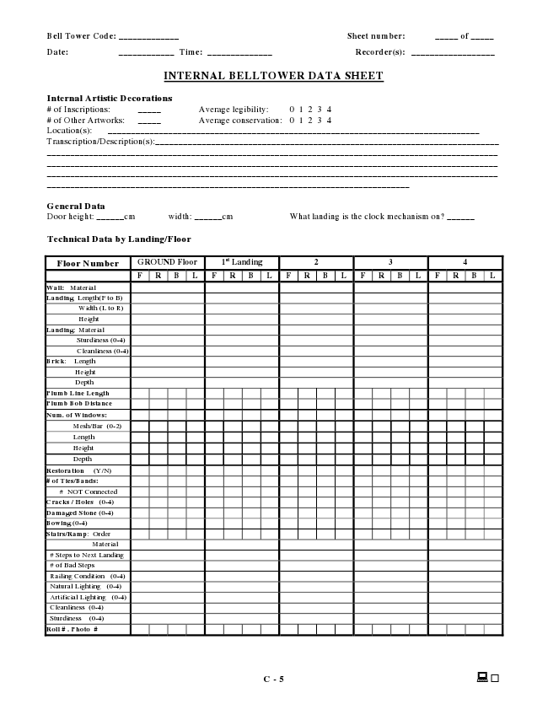

**Bell Tower Code: _____________ Sheet number: _____ of _____**

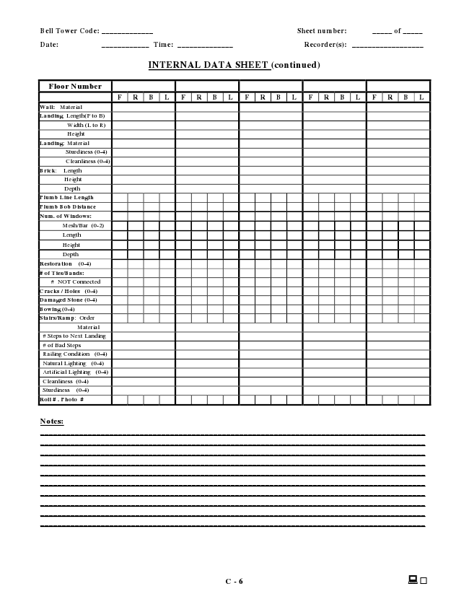

**Bell Tower Code: _____________ Sheet number: _____ of _____**

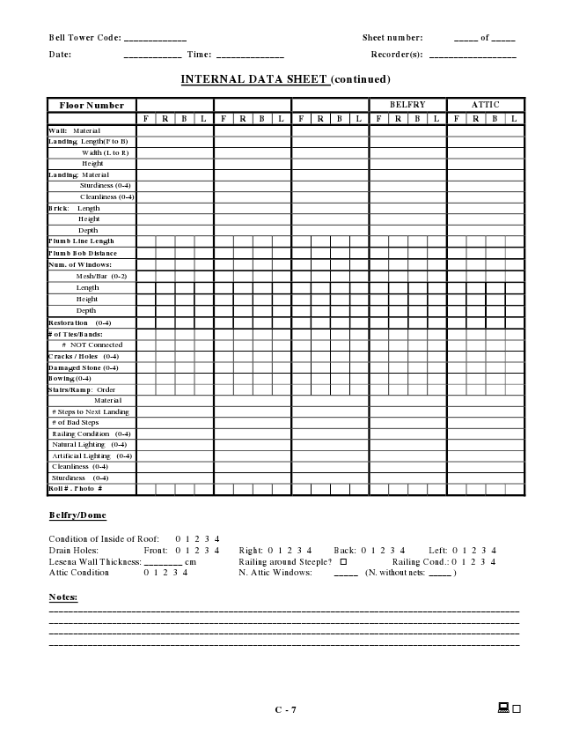

**Bell Tower Code: _____________ Sheet number: _____ of _____**

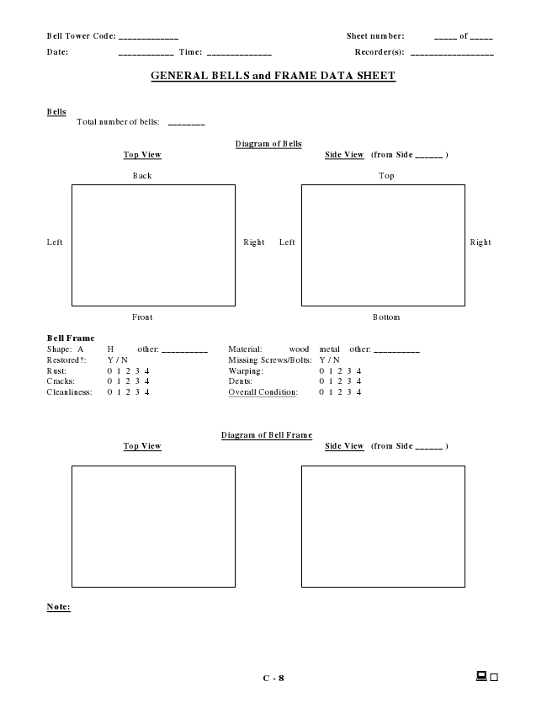

**Bell Tower Code: _____________ Sheet number: _____ of _____**

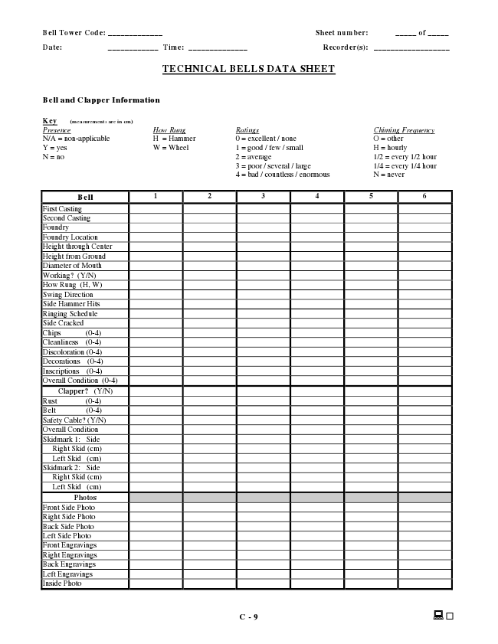

**Bell Tower Code: _____________ Sheet number: _____ of _____**

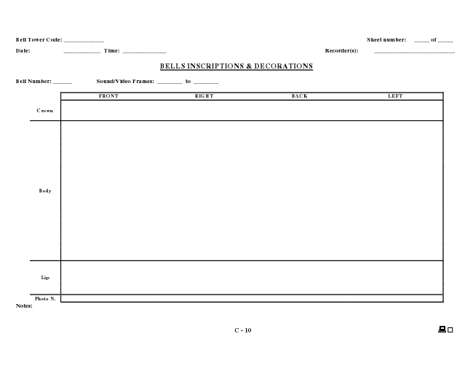

**Bell Tower Code: _____________ Sheet number: _____ of _____**

# Appendix D: Week One Schedule

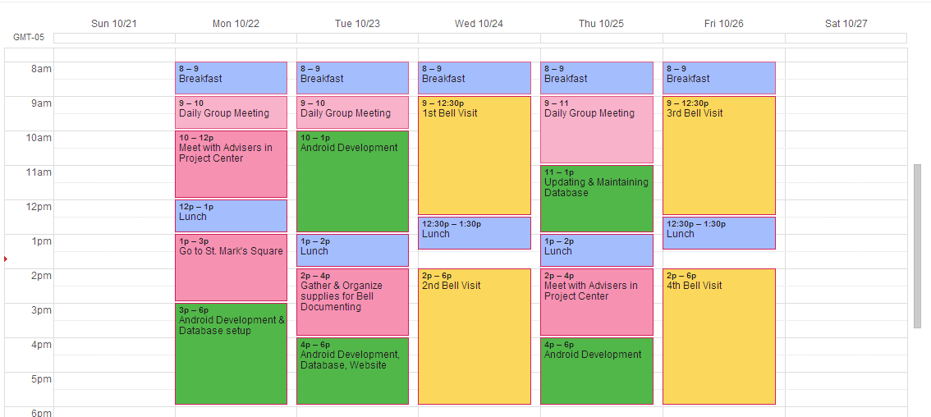

**pink: meeting**

**green: development work**

**yellow: bell tower visit/documenting**

**blue: meal time**

# Appendix E: Our Tentative B term schedule

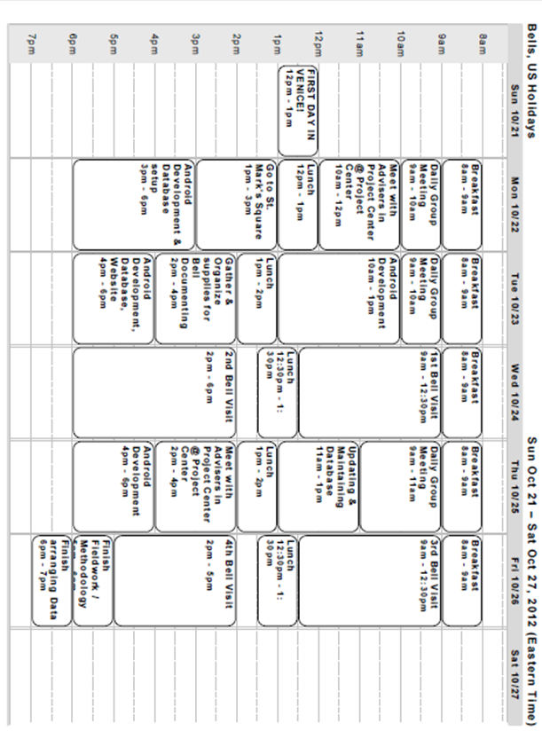

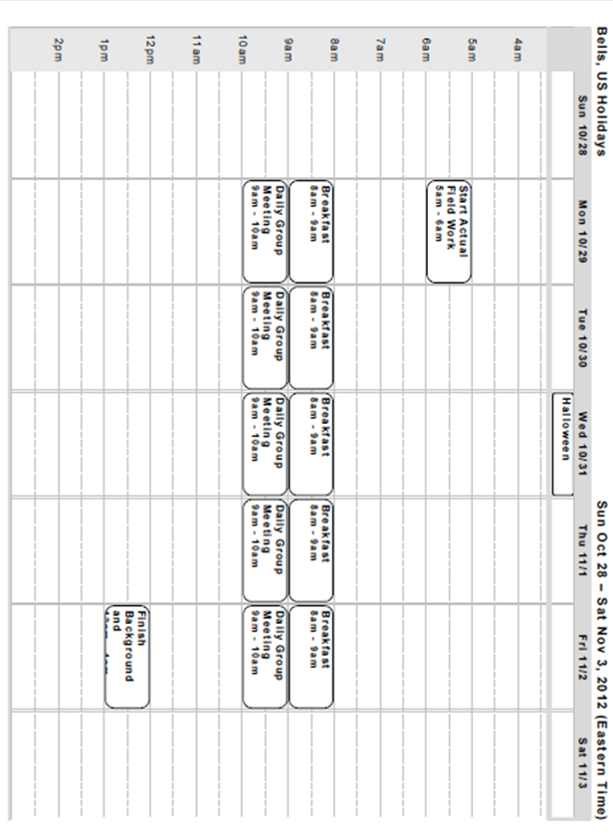

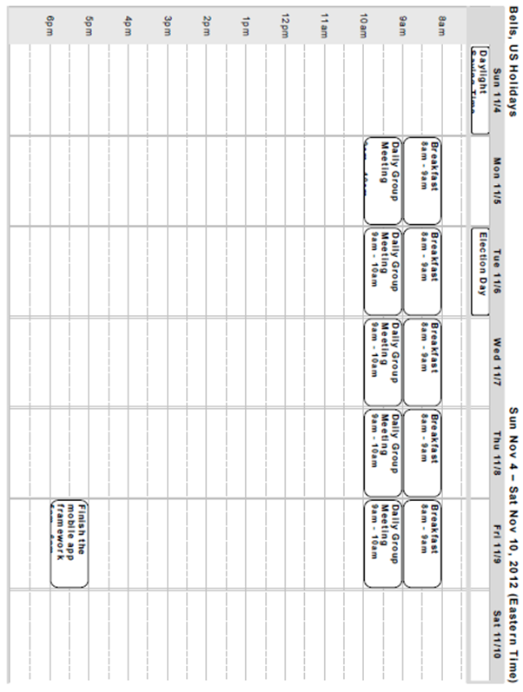

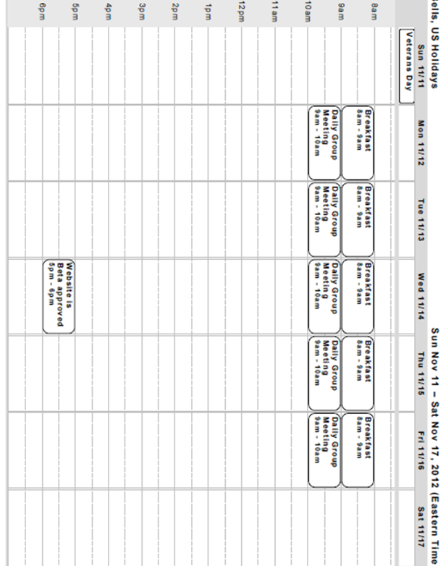

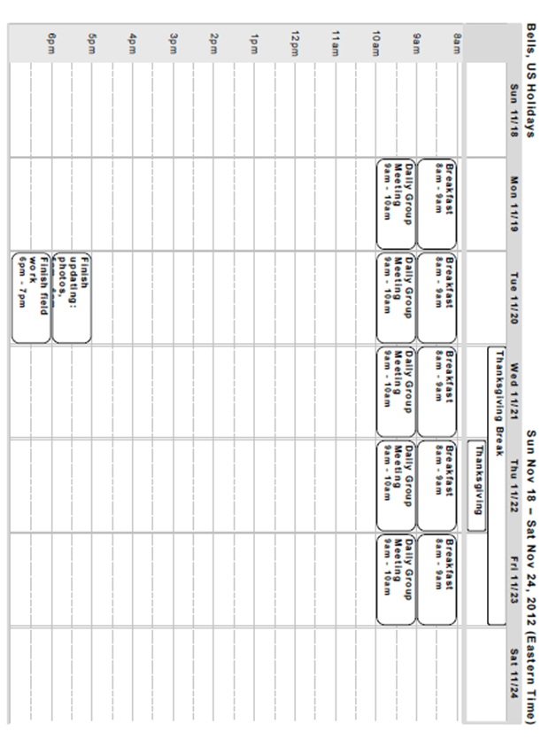

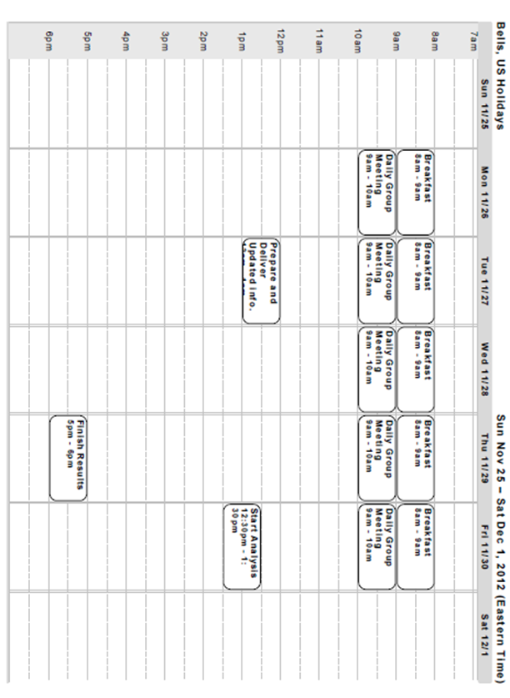

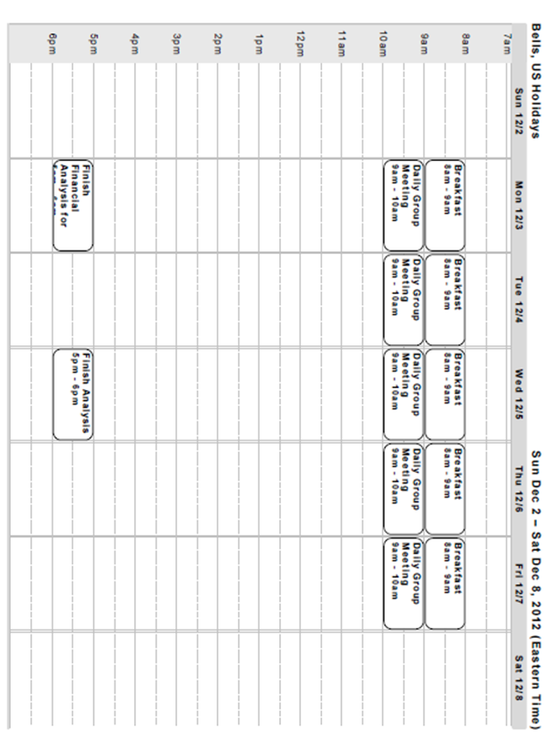

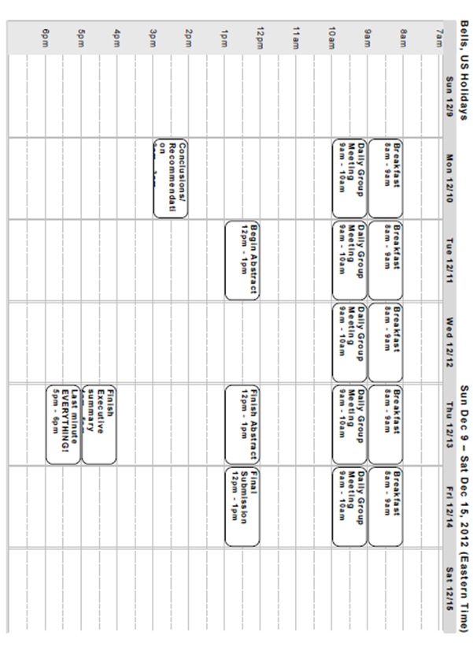

1. Alfred Gatty, “The Bell: It’s Origin, History, and Uses”, 5-7.
2. Alfred Gatty, “The Bell: It’s Origin, History, and Uses”, 2.
3. whc.unesco.org.
4. Saleh Lamei, “Insights into Current Conservation Practices”.
5. Richard Babyak, “Reinventing the Bell Tower”, 2005, 5.
6. Ibid.
7. Ibid.
8. Ibid, 22.
9. Ibid, 22.
10. www.verdin.com, 2012.
11. Ibid, 22.
12. Ibid, 23.
13. Ibid, 23.
14. Strafford, Newell, Audy, Audy, 23.
15. Ibid, 25.
16. Tyack, “*A Book about Bells”,* 1898, 63.
17. Ibid, 70.
18. Ibid, 77.
19. Scott, David A., “Bronze Disease: A Review of some Chemical Problems and Role of Relative Humidity”, 193-206.
20. Hedberg, Yolanda, “Protective Green Patinas on Copper in Outdoor Constructions”, 956-959.
21. Ibid.
22. De Oliveira, F, “Study of Patina Formation on Bronze Specimens”, 761-770.
23. Hamilton, Donny L., “Methods of Conserving Archaeological Material from Underwater Sites”, 74.
24. Ibid.
25. De Oliveira, 761-770.
26. Hedberg, 956-959.
27. Fitzgerald, K.P., “The Chemistry of Copper Patination”.
28. Scott, 193-206.
29. Heywood, Arthur Percival, e.t al, “*Bell Towers and Bell Hanging, An Appeal to Architects*”, 43.
30. Ibid, 43.
31. Ibid, 44.
32. Ibid, 44.
33. *Encyclopedia Britannica*, s.v. “Bell.”.
34. Ivorra, Salvador, e.t al “*Dynamic Forces Produced by Swinging Bells*”, 47.
35. *Encyclopedia Britannica*, s.v. “Bell.”.
36. Ivorra, Salvador, e.t al “*Dynamic Forces Produced by Swinging Bells*”, 47.
37. Ibid, 48.
38. Ibid, 48.
39. Strafford, Newell, Audy, Audy, 26.
40. Ibid, 26.
41. Ibid, 26.
42. Ibid, 26.
43. Ball, Dr. Steven, “*The Defense of Bells*”, 20.
44. Ibid, 20.
45. Ibid, 21.
46. Ibid, 21.
47. Ibid, 24.
48. Ibid, 24.
49. Ibid, 25.
50. Americlock, Inc., “*Church Bell Ringing & Bell Strikers*” 1990-2012, http://www.usbellco.com/bell-strikers.
51. Knopf, Venice, 1993, 84.
52. Jeff Cotton, “San Marco”.
53. Angelo D’Ambrisi, “Seismic assessment of a historical masonry tower with nonlinear static and dynamic analyses tuned on ambient vibration tests”.
54. G. Russo., "Experimental Analysis of the “Saint Andrea” Masonry Bell Tower in Venice. A New Method for the Determination of ‘Tower Global Young’s Modulus E’”.
55. Albert J. Ammerman, “Saving Venice”.
56. Laura Carbognin, "Global Change and Relative Sea Level Rise at Venice: What Impact in Term of Flooding."
57. Laura Carbognin, "Global Change and Relative Sea Level Rise at Venice: What Impact in Term of Flooding."
58. Michael Freemantle. "Safeguarding Venice.”
59. Monclús 2006, 21.
60. Baca 2006, 3.
61. Ibid, 2.
62. Ibid, 3.
63. Ibid, 7.
64. Ibid, 8.
65. Tascam, “Handheld 4-Track Recorder: Giving You Flexibility Needed to Record Anywhere.”
66. Ericsson, "Interim Traffic and Market Data Report Covers Growth in Subscriptions, Voice Traffic and Mobile Data."
67. William L. Hosch, *Smartphone*.
68. M. White, "Information Anywhere, any when: The Role of the Smartphone."
69. [citation needed]
70. Ericsson.